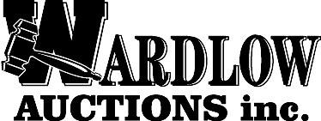 Broker Participation Form – Terms & Conditions

Property to be auctioned: 1777 Bernheim Ln. Louisville, KY 40210

Date of auction: Online bidding closes Monday, October 13, 2025 at 12:00 p.m.

A commission of 2% of the final bid price will be paid to the broker whose registered client is the winning bidder and buyer of the above property being sold at online auction. The conditions under which this commission is offered and paid are as follows:

1. This form must be completed and submitted to the Seller’s agent before 11:00 a.m. Monday, October 13, 2025. No oral registrations will be accepted.

2. The registered client must be the winning bidder.

3. The transaction must close.

4. This fee is not offered to a broker/salesperson involved as a principal in the purchase of the property. Broker/salesperson and client hereby attest that broker/salesperson is serving as agent for the buyer and not as a principal or any other capacity as a buyer of the property.

5. By signing this form, all parties indicate that they are aware of and understand the terms of the auction.

Client’s name (printed) Client’s signature Date

Broker/salesperson’s name (printed) Broker/salesperson’s signature Date

(office) (cell)

Broker’s company name Broker/salesperson’s phone number

**Please email the completed and scanned form to Stacie@wardlowauc.com.**

If you have any questions, please phone Wardlow Auctions, Inc. (502) 489-5515 or Stacie Hewitt (502) 203-5664.