

**REAL ESTATE AUCTION**

**1.75± Commercial Acres on Princess Anne Street**

**in Downtown Fredericksburg, VA**

**ONLINE ONLY BIDDING!!**

**2015 Princess Anne St., Fredericksburg, VA 22401**

**Online Only Bidding Closes**

**Tuesday, October 15, 2024 @ 10am (Eastern)**

***For information contact: Tony Wilson, Auction Coordinator – (540) 748-1359***

**Nicholls Auction Marketing Group**

**Offices throughout Virginia and affiliates nationwide to meet your needs.**  
**VAAF #2908000729 VAAF#2908000769**

**On the web at:** [**www.nichollsauction.com**](http://www.nichollsauction.com/)

**Contact us by E-mail at:** [**info@nichollsauction.com**](mailto:info@nichollsauction.com)

***Why use Nicholls Auction Marketing Group to sell your property?***

Nicholls Auction Marketing Group has set and maintained an overall sales ratio in excess of 95% since 1980. Our standards for conducting an auction are simply higher, and the marketplace has responded, allowing us to be the leader in getting properties sold and closed. For property owners who are serious about selling—who wish to maximize their returns while reducing the time, risk and frustration of trying to sell through a traditional approach—our customized individual owner services are a perfect fit.

Nicholls Auction Marketing Group will customize and execute a results oriented auction marketing campaign that maximizes exposure and creates active competition for the purchase of your property. This results not only in full and current market value, but also preserves opportunities for greatest price, while limiting risk of lower price. Individual sellers also benefit from the convenience of controlled viewings, standardized terms and conditions of sale, and a known sale and closing date.

Our 55+ years experience is broad-based allowing us to bring together the necessary resources for a successful sale of practically any type of real, as well as personal property. For more information please go to nichollsauction.com and allow us the privilege to add your name to our growing lists of satisfied clients.

Nicholls Auction Marketing Group

***Premier Service Since 1968***



**Property Location 2015 Princess Anne St., Fredericksburg, VA 22401**

**Auction Date & Time Online Only Bidding Closes**

**Tuesday, October 15, 2024 @ 10am (Eastern)**

**Property Tour Please preview at your leisure, and contact Tony Wilson for more information (540-748-1359)**

**Description BID NOW!! ONLINE ONLY BIDDING!!**

**Valuable 1.75 +/- acres of commercial land -- Zoned CM -- Town home & business possibilities -- Amazing location in the heart of historic Fredericksburg and across from the historic landmark Carl's Frozen Custard, the rear of the property fronts the Rappahannock River Heritage Trail & Caroline St., .5 mile from James Monroe HS, walking distance to downtown restaurant district & Old Mill Park, 1 mile from University of Mary Washington & Mary Washington Hospital, 2.5 miles to I-95, 4 miles to Rt. 3, and a short drive to NOVA, DC & Richmond, VA!!**

**Auction Note *Please bid early and often & understand the online only bidding begins to close on Tuesday, October 15, 2024 @ 10:00 AM (Eastern).***

* 1.75 +/- acres of valuable commercial land on Princess Anne St. in downtown historic Fredericksburg, VA
* 70' & 40' of frontage on Princess Anne St. and 200' +/- of frontage on Heritage Trail/Caroline St.
* Please visit the auction webpage for information on CM zoning (pg. 7)
* Environmental site assessment, proposed site plans & survey can be found in the "Documents" tab above
* Amazing location in the heart of historic Fredericksburg and across from the historic landmark Carl's Frozen Custard, the rear of the property fronts the Rappahannock River Heritage Trail & Caroline St., .5 mile from James Monroe HS, walking distance to downtown restaurant district & Old Mill Park, 1 mile from University of Mary Washington & Mary Washington Hospital, 2.5 miles to I-95, 4 miles to Rt. 3,  and a short drive to NOVA, DC & Richmond, VA!!
* Tax Map:  23-B2015; Deed Book:  0018-25; Yearly real estate taxes:  $5,870 (2023); **$50,000 deposit (wired funds or certified check ONLY)**is due immediately after confirmation of final bid and the balance due at closing within 45 days;  **WE GUARANTEE A FREE & CLEAR DEED**
* **Only $500,000 Starting Bid!!**

**Property Tour Please preview at your leisure, and contact Tony Wilson for more information (540-748-1359)**

**Approval to Bid Approval to bid is subject to completing an on-site or on-line bidder registration form and verification of the required earnest money deposit by auction personnel. The approval of online bidders is subject to confirmation by the auction coordinator.**

**Earnest Money Online Terms: A $50,000 earnest money deposit will be required from the successful purchaser. At the close of the online auction, and seller confirmation, the successful bidder will be emailed or given the contract package to execute and return to Nicholls Auction Marketing Group, Inc. Upon being declared the high and successful buyer, the credit card that you registered with will be charged $500 toward your deposit. The successful bidder’s remaining earnest money deposit ($49,500) must be in the form of cashier’s or certified check (United States Bank) or wire transfer to Nicholls Auction Marketing Group, Inc. and is due immediately. The entirety of the remaining balance is due at closing. Purchaser shall be responsible for all wire transfer fees. You may be asked to show proof of funds for the deposit (via text or email) prior to being approved to bid.**

**Closing** Time being of the essence, these sales shall be closed on or before 45 days from auction date. The purchaser will pay for all of their closing costs associated with the transaction.

**Financing** Need financing for these properties? Contact Tony Wilson for financing information (540) 748-1359.

**Real Estate Salesperson** Although not required, if a buyer has been working with a real estate

**Acknowledgment** agent, the real estate agent must complete the Auction Bidder Representation Form. In order for the real estate agent to be compensated, the Auction Bidder Representation Forms must be completed and submitted no later than 6 am on the day of the auction (10/15/24) (no exceptions), and all terms adhered to. A registered real estate agent can only represent one buyer at each auction event. Registered real estate agent must attend all auction events with a live bidding component regardless if their bidder/buyer is bidding live in person on site or off site bidding on line and adhere to all terms.

**Auctioneers Note** All information and dimensions were derived from sources believed to be correct, but are not guaranteed. Buyers shall rely on their own information, judgment, and inspection of the property. All auction day announcements take precedence over any previously printed material or any other oral statements made.

**Can’t Attend?** Can’t attend the auction, but still want to bid? No problem! Download our app in the Apple App Store, Google Play Store, or use your web browser to register and bid during the live auction.

**Notes** 1.

2.

3.

2015 Princess Anne St., Fredericksburg, VA 22401

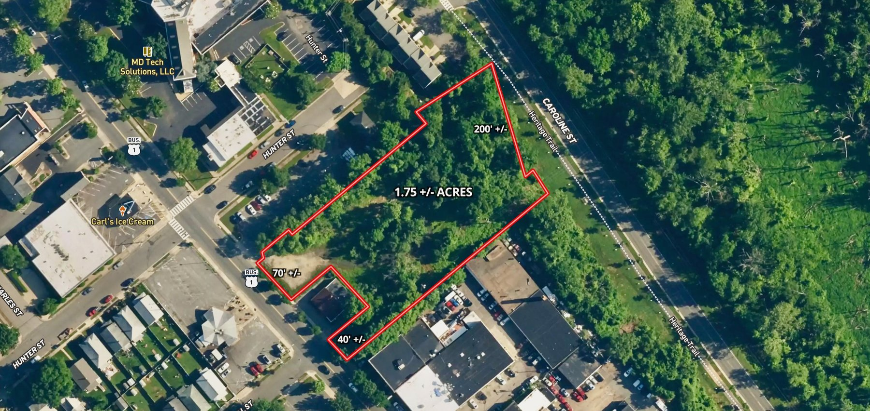

Terms and Conditions

**TERMS:**  Thank you for your interest in this property. Contact Tony Wilson if you need additional information (540-748-1359).

This online auction is not contingent on or subject to financing, appraisal, survey (property lines), study period or inspections of any kind, as agreed to by bidders at registration prior to bidding, and specified in the Offer to Purchase and Contract. Property is sold in as-is condition with no warranties or guarantees of any kind.

Per the contract, “TIME IS OF THE ESSENCE,” and you should proceed to closing immediately. You must close the transaction on or before 45 days from auction date.  If your closing is delayed for any reason, by you, as purchaser, or other parties working on your behalf, including any lender you involve – you may be declared in breach of the contract, forfeit all deposits made, and could be additionally liable for any and all court costs, any price difference in a subsequent resale of the property, and all future auction costs incurred by the seller and Nicholls Auction Marketing Group, Inc.

Bid with confidence, but please do not delay your closing!

Terms & Conditions

Contract for Sale of Real Property: This property is offered under the specific terms provided in the contract. The Contract for Sale of Real Property is available at www.nichollsauction.com in the property information packet package located from within the “DOCUMENTS” section. Please read and review the contract thoroughly prior to bidding on any property. If you have not read and reviewed the Contract for Sale of Real Property, Do Not Bid!

Nicholls Auction Marketing Group, Inc. has the sole authority to resolve any bidding disputes as they may arise.

Bidder Verification: The identity of all bidders will be verified, bidding rights are provisional, and if complete verification is not possible, Nicholls Auction Marketing Group, Inc. will reject the registration, and bidding activity will be terminated.

**Online Terms: A $50,000 earnest money deposit will be required from the successful purchaser.  At the close of the online auction, and seller confirmation, the successful bidder will be emailed or given the contract package to execute and return to Nicholls Auction Marketing Group, Inc. Upon being declared the high and successful buyer, the credit card that you registered with will be charged $500 toward your deposit. The successful bidder’s remaining earnest money deposit ($49,500) must be in the form of cashier’s or certified check (United States Bank) or wire transfer to Nicholls Auction Marketing Group, Inc. and is due immediately. The entirety of the remaining balance is due at closing. Purchaser shall be responsible for all wire transfer fees. You may be asked to show proof of funds for the deposit (via text or email) prior to being approved to bid.**

Auction/Buyer’s Premium: A 10% auction/buyer’s premium will be added to the final bid price to determine the total contract price. 10% Auction/Buyer’s Premium Example: Bid Price: $100,000 Plus 10% Auction/Buyer’s Premium: $10,000 Total Contract Price: $110,000. The auction/buyer’s premium is non-negotiable.

Contracts: Contract Packages will be sent by e-mail to the high bidder, who must execute and email, fax or overnight mail back to Nicholls Auction Marketing Group, Inc., within 24 hours of receipt. If the successful bidder does not execute and return their contract with earnest money deposit within 24 hours of receipt they will be considered in default and subject to legal action. This is a legal binding contract.

Auction Administrative Fee: In the event a winning bidder fails to submit the signed ’Contract for Sale of Real Property’ and deposit earnest money as provided in the pre-stipulated Auction Terms, the winning bidder will be charged an administrative fee of $50,000 on the credit card provided at auction registration. Additional default remedies are reserved by Nicholls Auction Marketing Group, Inc., and the Seller as provided in the Auction Terms & Conditions and the ‘Contract of Purchase’. All administrative fees are non refundable.

Closing: Time being of the essence, these sales shall be closed on or before 45 days from auction date.  The purchaser will pay for all of their closing costs associated with the transaction.

Agency Disclosure: In all transactions, the auctioneer is acting as agent for the seller, not as buyer’s agent. Nicholls Auction Marketing Group, Inc. reserves the right to remove or cancel the bids and or bidding rights and privileges of any party, deemed not to be in the best interest of the seller, at any time. At auctions with reserve, the seller and/or auctioneer reserves the right to bid.

Disclaimer: All information contained herein is believed to be correct to the best of the auctioneer’s knowledge. The information is being furnished to bidders for the bidder’s convenience and it is the responsibility of the bidder to determine that information contained herein is accurate and complete.

Any reliance on the contents shall be solely at the recipient’s risk. Bidders must conduct and rely solely upon their own investigations and inspections. The property is being sold ’AS IS’ with any and all faults. Please review all information supplied, and seek appropriate assistance prior to bidding.

Realtor Representation: Pre-approved (no later than 6:00 am Eastern on 10/15/24) realtor representation is compensated. Real estate agent must fill out and submit realtor representation form by time stated above and adhere to all rules in order to be compensated.

Technical Issues: Neither the company providing the software nor the auction company shall be held responsible for a missed bid or the failure of the software to function properly for any reason. The online bidding and virtual auction will begin to close on ***Tuesday, October 15, 2024 @ 10:00AM (Eastern).***  In the unfortunate event of a DDOS attack or server attack/shut down, the auction company reserves the right, but is not required, to change the bid closing deadline.