Home Inspection Summary / Report

6611 Twin Cedars Court
Fredericksburg, Virginia, 22407
December 27, 2021

This is a beautiful single-story home. There are a few issues (please see attached notes and pictures) that I have highlighted. With the repairs noted and a few upgrades, this could be a good investment as well as a great place to live. Should you have any questions or concerns, please do not hesitate to contact me.

Report 583

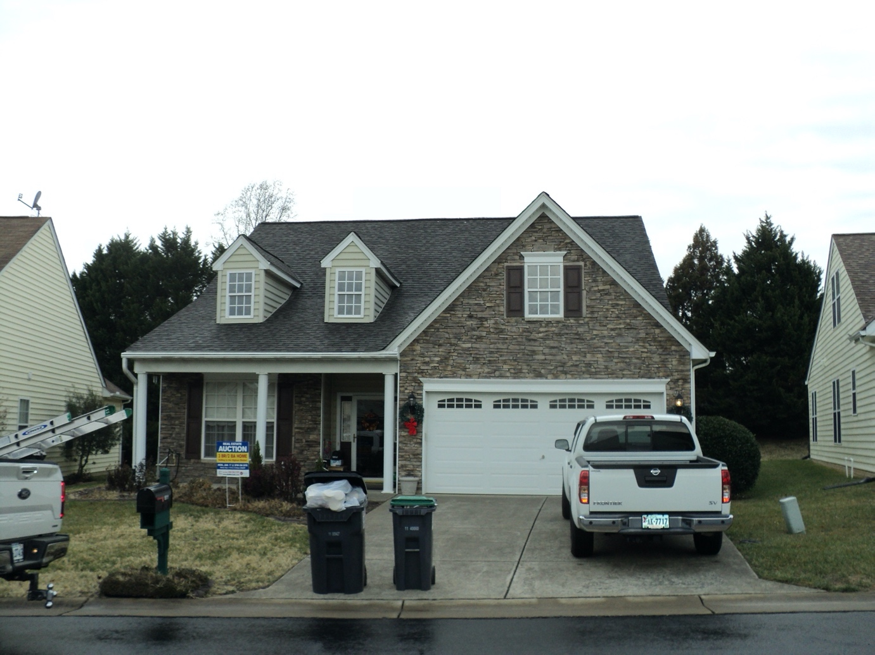

₍₁₎

HOME INSPECTION AGREEMENT
A member of the Housing Inspection Foundation prepared this Agreement,
The Association of Home Inspectors

Inspector’s Name: Jesse Dodd Professional Membership# 23096
Company: Home Inspections Report # 583
Address: 123 Sunny Day Lane
City: Fredericksburg State: Virginia Zip: 22406
Cell: (703) 929-3400 Email: jessedodd99@yahoo.com

THIS INSPECTION AGREEMENT IS INTENDED TO BE A LEGALLY BINDING CONTRACT.
PLEASE READ IT CAREFULLY.

Client Name (s): Tony Wilson
Property Address 6611 Twin Cedars Court Fredericksburg, Va. 22407
Client’s Telephone 540-748-1359
Client’s e-mail tony@wilsonauctionco.com
Realtor:
- Client requests a limited visual inspection of the residential structure identified at the above address by the listed inspector of the above company, herein after collectively referred as the “Company” and Client hereby represents and warrants that all approvals necessary have been secured for Company’s entrance on to the property.
- Client warrants: (a) they have read the following Agreement carefully, (b) they understand they are bound by all the terms of this contract, and (c) they will read the entire inspection report when received and promptly call Company with any questions they may have.
- Client understands that the inspection and inspection report are performed and prepared for their sole, confidential, and exclusive use. Client agrees that they will not transfer or disclose any part of the inspection report to any other person with these exceptions ONLY. (a) One copy may be provided to the current seller(s) of the property. Only upon the express condition that the seller(s) covenant to use the inspection report only in connection with Client’s transaction. And agree not to transfer or disclose the report to any persons other than their real estate agent, and (b) one copy may be provided to the real estate agent representing Client and/or a bank or other lender for use in Client’s transaction only. Client agrees to indemnify, defend, and hold harmless Company from any third-party claims relating to this inspection or inspection report.
- Company agrees to perform a limited visual inspection of the residential structure at the above address and to provide Client with a written opinion as to the apparent general condition of the structure’s components and systems, including identification of significant observable deficiencies, as they exist at the time of inspection. The inspection will be performed in a manner consistent with the standards of the Housing Inspection Foundation. Copies of these Standards are provided to Client, upon request.
- The inspection only includes those systems and components expressly and specifically identified in the inspection report. Any areas which is not exposed to view, is concealed, is inaccessible because of soil, walls, floors, carpets, ceilings, furnishing of any other thing, or those areas/items which have been excluded by the Housing Inspection Foundation standards and/or by agreement of the parties is not included in this inspection. The inspection does not include any destructive testing or dismantling. Client agrees to assume all the risk for all conditions, which are concealed from view at the time of the inspection or exists in any area excluded from inspection by the terms of this agreement. Maintenance and other items may be discussed but will NOT form a part of the inspection report. The following areas/items, systems and components are among those NOT included in the inspection:
  - Code or zoning violations
  - System or component installation
  - Permit research
  - Structural, geological, soil, wave action or hydrological stability, survey, engineering, analysis, or testing
  - Termites or other wood destroying insects, rodents or other pests, dry rot, or fungus
  - Latent or concealed defects
  - Asbestos, radon gas, lead paint, urea formaldehyde, toxic or flammable chemicals, water or air quality, PCB’s or other toxins, electro-magnetic fields, underground storage tanks, proximity to toxic waste sites or other environmental or health hazards
  - Private water or sewage systems
  - Pools, spas, hot tubs, saunas, steam baths, fountains, or other types of or related systems and components
  - Repair cost estimates
  - Building value appraisal
  - Radio controlled devices
  - Automatic gates
  - Elevators, lifts, dumbwaiters
  - Thermostatic or time clock controls
  - Water softeners or purifiers
  - Radiant heat systems
  - Furnace heat exchanger
  - Solar heating systems

Copyright 2001 Housing Inspection Foundation. This form may be reproduced without written consent; however, the Housing Inspection Foundation must be acknowledged and credited.

(2)
HOUSING INSPECTION REPORT

THIS INSPECTION AGREEMENT IS INTENDED TO BE A LEGALLY BINDING CONTRACT.
PLEASE READ IT CAREFULLY.

SEE PAGES 14 &15 FOR IMPORTANT LIMITATIONS, DISCLAIMERS, AND INFORMATION.

INSPECTOR Jesse Dodd

THIS REPORT IS OUR INVOICE INSPECTION FEE $ 350.00 Paid 12/27/2021

TERMS: Cash Check # 6631 Money order Credit Card
BUYER’S Tony Wilson DATE December 27,2021 Time 10;00 am
PROPERTY ADDRESS 6611 Twin Cedars Court CITY Fredericksburg STATE Virginia Zip 22407

X OCCUPIED VACANT X SINGLE-STORY TWO-STORY TOWNHOUSE/CONDO
SPLIT-LEVEL BASEMENT FINISHED UNFINISHED CRAW-SPACE X SLAB

MECHANICAL APPLIANCES NOTE: THE FOLLOWING IS NOT INCLUDED IN THIS INSPECTION: CLOCKS, TIMERS AND AUTOMATIC COOKING OR CLEANING MODES OR INTERCOM, COMMUNICATION MODES. MICROWAVES will not be CHECKED FOR RADIATION LEAKAGE.

Not Needs Works as
Inspected Repair Intended

 |  | OK | COOK TOP/RANGE GAS X ELECTRIC
 |  | OK | BURNERS_______
 |  | OK | OVEN X SELF CLEAN CONTINUOUS CLEAN MANUAL CLEAN
 |  | OK | SETTING___ TEMP_______
 |  | OK | MICROWAVE
 |  | OK | KITCHEN EXHAUST VENTED X NON-VENTED
 |  | OK | GARBAGE DISPOSAL
 |  | OK | DISHWASHER
 |  | OK | REFRIGERATOR
 |  | OK | ICE MAKER X FREEZER X FREE-STANDING
O |  |  | TRASH COMPACTOR
O |  |  | INTERCOM
O |  |  | GAS GRILL
O |  |  | CENTRAL VACUUM

NOTE: PIPES, PLUMBING EQUIPMENT AND RESERVOIRS CONCEALED IN ENCLOSURES OR UNDER GROUND, NOT CHECKED FOR LEAKS OR DEFECTS-ALSO-THE SERVICEABILITY OR CONDITION OF THE SEPTIC OR SEWER SYSTEM IS NOT INCLUDED IN THIS INSPECTION. SPRINKLER SYSTEMS ARE ONLY CHECKED IN THE MANUAL OPERATION MODE. POOL PLUMBING SYSTEMS ARE NOT LEAK CHECKED.
PLUMBING, OUTSIDE
O |  |  | METER-MAIN SHUT-OFF
 |  | OK | OUTSIDE FAUCETS (2)
O |  |  | SPRINKLER SYSTEM BACKFLOW PREVENTER ANTISIPHON VALVE NO. STATIONS () WINTERIZED
O |  |  | OIL LINE CHECK VISUAL 5-MINUTE CHECK
 |  | OK | GAS LINE CHECK VISUAL 5-MINUTE CHECK
O |  |  | WATER METER CHECK VISUAL 5-MINUTE CHECK
O |  |  | DRAIN FIELD
 |  |  | WELL
 |  | X | COUNTY WATER
©Copyright 2001 Housing Inspection Foundation Housing Inspection Form #2700 7/99

(3)
PLUMBING, INSIDE NOTE: PIPES AND PLUMBING IN WALLS, IN OR UDER CONCRETE SLABS OR CONCEALED BY PERSONAL EFFECTS AND THEIR QUALITY, CONDITION ORPURIFICATION OF WATER IS NOT INCLUDED IN THIS INSPECTION.

 |  | OK | KITCHEN FAUCET & DRAIN
O |  |  | UTILITY FAUCET & DRAIN
 |  | OK | LAVATORIES (2)
 |  | OK | TUBS (1)
 |  | OK | SINKS (2)
 |  | OK | SHOWERS (3)
 |  | OK | COMMODES (2)
 |  | OK | WATER HEATER (X) GAS () ELECTRIC SIZE 40 Gallons No. OF UNITS, One
 | X |  | WATER HEATER PAN AND OVERFLOW DRAIN See notes on water heater.
 |  | OK | TEMPERATURE & PRESSURE VALVE OPERATION
O |  |  | WATER CONDITIONER PLUMBING
 |  | OK | WATER HEATER LOCATION Garage.
 |  | OK | MAIN WATER SHUT OFF LOCATION Garage.

NOTE: LIGHTS AND EQUIPMENT ACTIVATED BY PHOTOCELL SWITCHES ARE NOT CHECKED. ALSO, LANDSCAPE AND EXTERIOR GROUNDS
ELECTRICAL LIGHTING IS NOT INCLUDED IN THIS INSPECTION. ANTIQUATED WIRING UPDATED. IT CREATES A POSSIBLE HAZARD.
OUTSIDE TYPE OF WIRING IN PANEL: () COPPER () ALUMINUM () CIRCUIT BREAKERS () FUSES

 |  | OK | SERVICE ENTRANCE / METER Right side of house.
O |  |  | SERVICE PANEL – LOCATION
O |  |  | SUB SERVICE PANEL – LOCATION
 |  | OK | GFCI-OUTLETS
O |  |  | POOL/SPA ELEC.
 |  | OK | OUTLETS

ELECTRICAL, INSIDE NOTE: ONLY REPRESENTATIVE NUMBER OF ACCESSIBLE OUTLETS IS CHECKED. SECURITY SYSTEMS ARE NOT INCLUDED IN THIS INSPECTION
.
 |  | OK | FIXTURES – SWITCHES AND OUTLETS
 |  | OK | BREAKER BOX – LOCATION Laundry room.
 |  | OK | DOORBELL/CHIME
 |  | OK | SMOKE DETECTORS
 |  | OK | GFCI (X) GARAGE (X) KITCHEN (X) BATHROOMS
O |  | OK | CARBON MONOXIDE TESTER Hall next to master bedroom.
O |  |  | BACK UP NATURAL GAS GENERATOR

FIREPLACE

 |  | OK | FIREPLACE (X) GAS () WOOD () OTHER.
O |  |  | WOOD STOVE
 |  | OK | (X) DIRECT VENT () NON-DIRECT VENT
 |  | OK | LINTEL-DAMPER-FLUE
 |  | OK | MANTEL FIXTURES - SWITCHES AND OUTLETS
 |  | OK | CHIMNEY
 |  | OK | CHIMNEY CAP
©Copyright 2001 Housing Inspection Foundation Housing Inspection Form #2700 7/99

(4)
HEATING NOTE: ONLY THE EMERGENCY HEAT MODE IS CHECKED ON HEAT PUMPS WHEN TEMPERATURE IS ABOVE 80º. WE RECOMMEND THE HEATING
SYSTEM IS COMPLETELY SERVICED BEFORE EACH HEATING SEASON. FILETERS SHOULD BE CHANGED, AS NEEDED (AT LEAST EVERY 2 MONTHS).
CHECKING HUMIFIDERS, ELECTRIC AIR FILTERS AND PROPER AIR FLOW BALANCE IS NOT INCLUDED IN THIS INSPECTION.

 |  | OK | (X) CENTRAL (X) GAS () FLR/WALL () ELECTRIC () RADIANT () HEAT PUMP () OIL.
 |  | OK | BURNER/ELEMENT
 |  | OK | () FLOOR VENTS (X) CEILING VENTS
 |  | OK | THERMOSTAT ‘S
O |  |  | BASEBOARD
 |  | OK | DUCT-WORK (X) METAL (X) FLEX
O |  | OK | NUMBER OF UNITS One.
 |  |  | BUILT IN HUMIDIFIYER
COOLING NOTE: AIR CONDITIONING UNITS ARE NOT CHECKED WHEN OUTSIDE TEMP IS BELOW 80º. WE RECOMMEND THE A.C. UNIT BE COMPLETELY
SERVICED BEFORE EACH COOLING SEASON AND THE CONDENSATE DRAIN BE FLUSHED WITH A CHLORINE BLEACH EVERY 2 MONTHS DURING
THE COOLING SEASON TO PREVENT CLOGGING.

 |  | OK | (X) CENTRAL () ZONED (X) REFRIGERATED () SASH/WALL (X) EVAPORATIVE
 |  | OK | NUMBER OF UNITS One
 |  | OK | COMPRESSOR
 |  | OK | CONDESNER – COIL & FAN
 |  | OK | CONDENSATE DRAIN
 |  | OK | THERMOSTAT
 |  | OK | CEILING FANS
O |  |  | ATTIC FANS () CEILING () ROOF
 |  | OK | BATH VENT FANS
O |  |  | WINDOW UNIT’
 | X |  | See notes on overflow pan drain line for AC unit in garage.

NOTE: FOUNDATION ON CLAY SOIL REQUIRES ADEQUATE AND EVEN MOISTURE AROUND THE PERIMETER FO THE FOUNDATION THE ENTIRE YEAR
TO PREVENT MOVEMENT. TREES AND SHRUBS CAN CAUSE FOUNDATION DAMAGE WHEN GROWING TOO CLOSE. WATER SHOULD NOT BE
PERMITTED TO POND OR ERODE, UNDER OR ALONG ANY PART OF THE FOUNDATION. DEPENDING ON THE DESIGN AND METHOD OF
STRUCTURAL ORIGINAL CONSTRUCTION OF A PIER AND BEAM FOUNDATION, THE FLOOR SYSTEM MAY NEED LEVELING PERIODICALLY.
FOUNDATION
 |  | OK | OBSERVATIONS
 |  | OK | VENTILATION Slab.
FOUNDATION DRAINAGE
OK
EXTERIOR WALLS
 |  | OK | (X) STONE (X) FRAME () BRICK () SHAKES (X) CONCRETE/CINDER BLOCK () STUCCO (X) POURED CONCRETE
 |  | OK | SIDING Viny-Stone.
GARAGE
 |  | OK | GARAGE DOOR OPENER
 |  | OK | AUTO REVERSE
 |  | OK | DOORS (X) METAL () WOOD

©Copyright 2001 Housing Inspection Foundation Housing Inspection Form #2700 7/99

(5)
ROOF
NOTE: WEATHER CONDITIONS, WIND, HAIL AND EXTREME TEMPERATURES AFFECT ALL ROOFING FROM DAY TO DAY, SO, CONTINUAL
OBSERVATION IS REQUIRED. () ASPHALT () WOOD SHINGLE () SLATE/TILE () BUILT-UP

 |  | OK | OBSERVATIONS
 |  | OK | PLUMBING VENT PIPES
 |  | OK | RIDGE VENT
 |  | OK | ROOF VENTS – RAIN CAPS
 |  | OK | GUTTERS – DOWNSPOUTS
 |  | OK | SOFFITS – FASCIA

ATTIC: ATTICS ARE NOT ALWAYS TOTALLY OBSERVABLE

 |  | OK | TRUSS ROOF SYSTEM (X) YES () NO
 |  | OK | RAFTERS – PURLINS – COLLAR TIES
 |  | OK | DECKING
 |  | OK | CEILING JOIST – RATER TIES (X) YES () NO
 |  | OK | INSULATION TYPE (X) BLOWN () BATT AVERAGE HEIGHT 20– 25 Inches. See note below.
 |  | OK | VENTILATION Ridge vent.
O |  |  | GABLE LOUVERS & SCREENS
O |  |  | TURBINES POWER VENTS
 |  |  | NOTE-New roof installation.
 |  | X | NOTE-New blown insulation was installed over the older blown insulation.

NOTE: ONLY A REPRESENTATIVE NUMBER OF ACCESSIBLE WINDOWS are CHECKED FOR OPERATION AT THIS INSPECTION. AS THERMAL PANE
WINDOWS LOSE THEIR VACUUM, MOISTURE MAY APPEAR, AND THEN DISAPPEAR, DEPENDING ON INSIDE AND OUTSIDE TEMPERATURE,
INTERIOR BAROMETRIC PRESSURE AND THE HUMIDITY LEVEL. THEREFORE, WINDOWS ARE LISTED AS OBSERVED AT TIME OF INSPECTION ONLY, AND NO
WARRANTY IS IMPLIED.

 | X |  | CEILINGS AND WALLS Some damage to sheetrock walls.
 | X |  | FLOORS Some damage to floor.
 | X |  | DOORS Some damage to doors and door trim.
 |  | OK | WINDOWS
 |  | OK | WATER PENETRATION No signs of present water penetration.

EXTERIOR
 |  | OK | WINDOWS
 |  | OK | DOORS
 |  | OK | WINDOW & DOOR TRIM
 | X |  | CAULK & WEATHER STRIP See notes on insulated wrap around AC lines.

POOL/SPA NOTE: POOLS & SPAS ARE CHECKED FOR EQUIPMENT ONLY, NOT LEAKAGE, POOL TIMER FUNCTION

O |  |  | () GUNITE () FIBERGLASS () VINYL
O |  |  | TYPE-COPING-DECK
O |  |  | HEATER
O |  |  | POOL SWEEP
O |  |  | DIVING BOARD () LADDER () SLIDE

©Copyright 2001 Housing Inspection Foundation Housing Inspection Form #2700 7/99

(6)

LAUNDRY ROOM

 |  | OK | WASHER HOOK-UP
 | X |  | WASHER OVERFLOW PAN & DRAIN No washer overflow pan and drain.
 |  | OK | DRYER HOOK-UP
 | X |  | DRYER VENT See notes on dryer exhaust vent cap.
O |  |  | DRYER (X) ELECTRIC () GAS

NOTES: PLEASE SEE ATTACHED NOTES AND PICTURES:

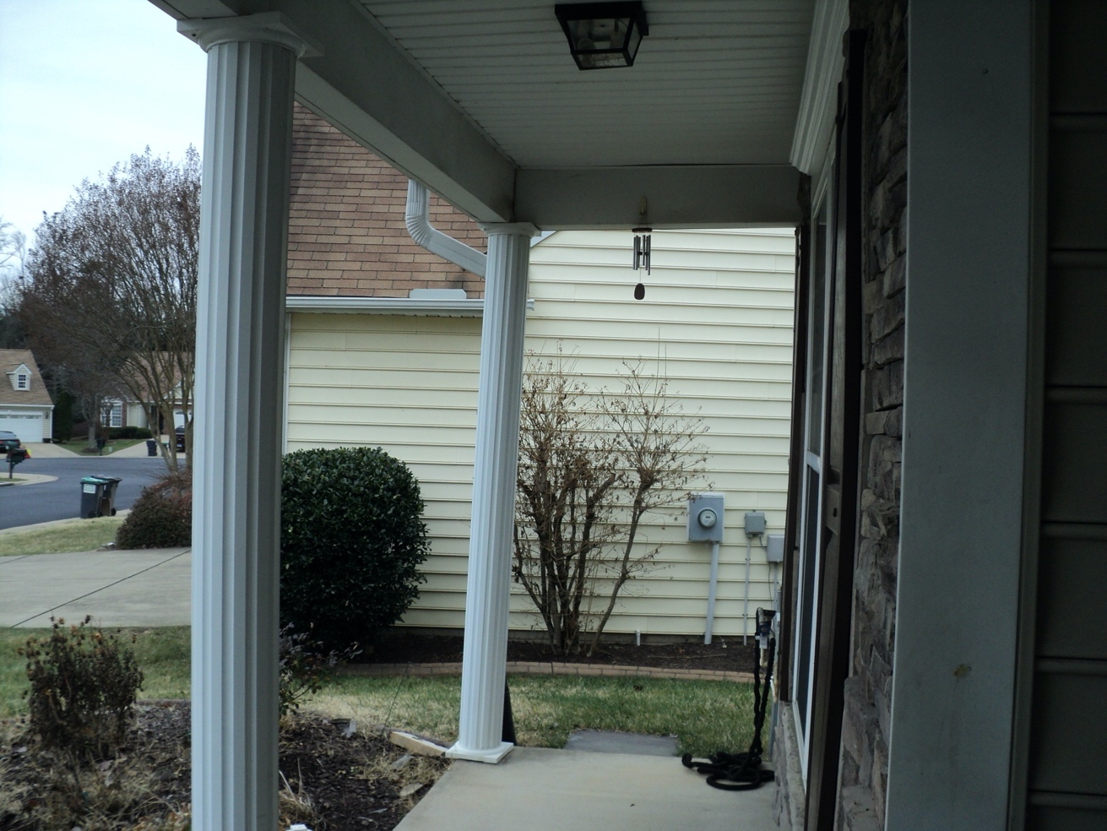

The corner post on the front porch is leaning. Most likely due to the motorized wheelchair. This can be easily tapped back into place with a block of wood and hammer.

(7)
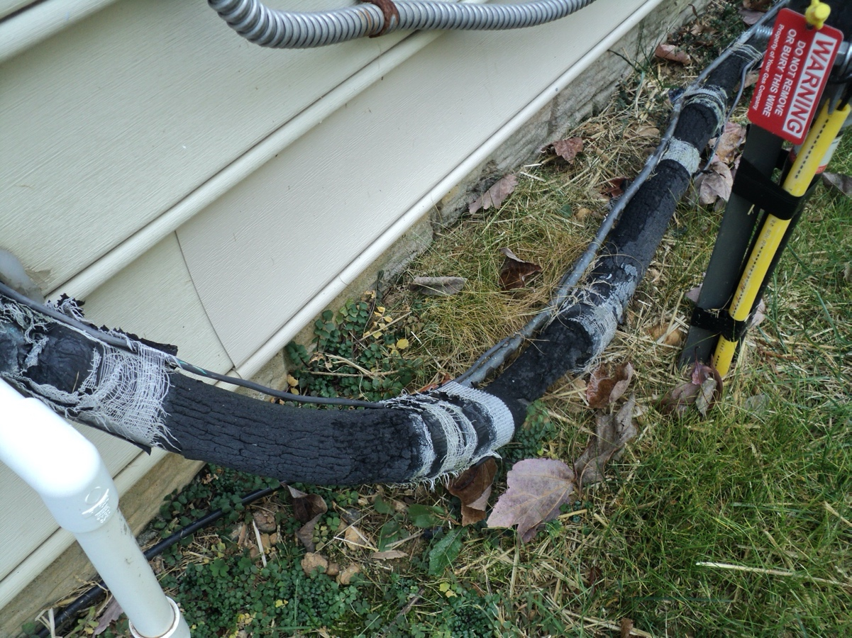

The insulated wrap around the AC lines has dry rotted and needs to be replaced.

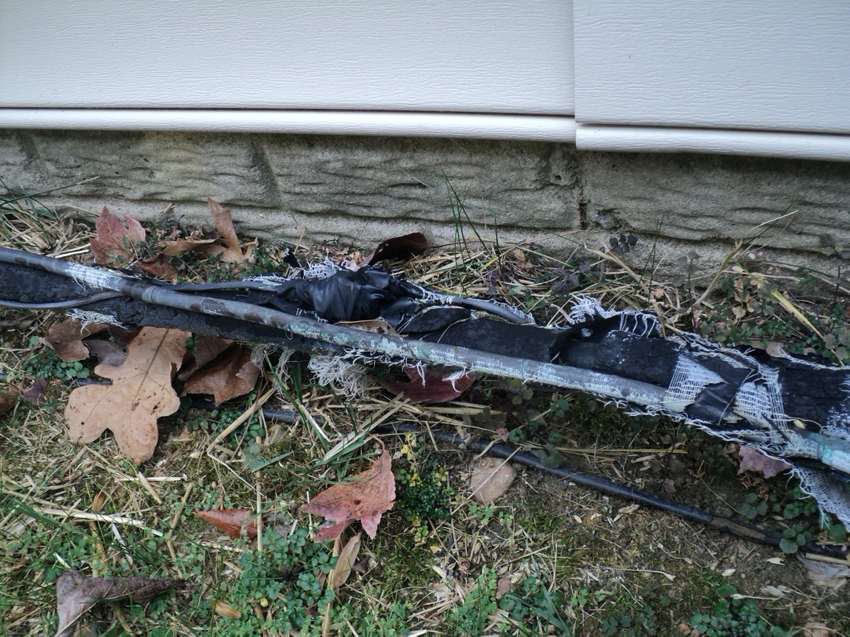

(8)
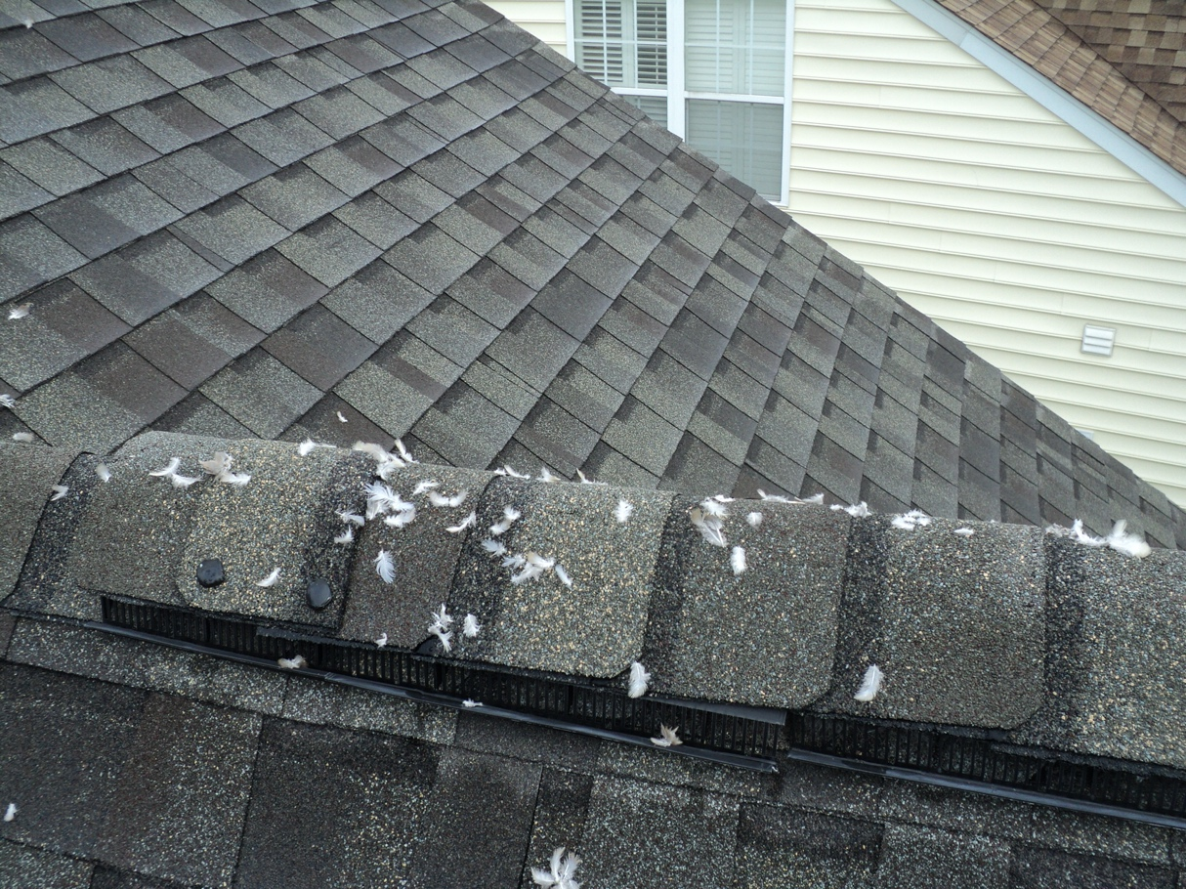

The peak of the new roof has small bird fethers scattered about in several places.

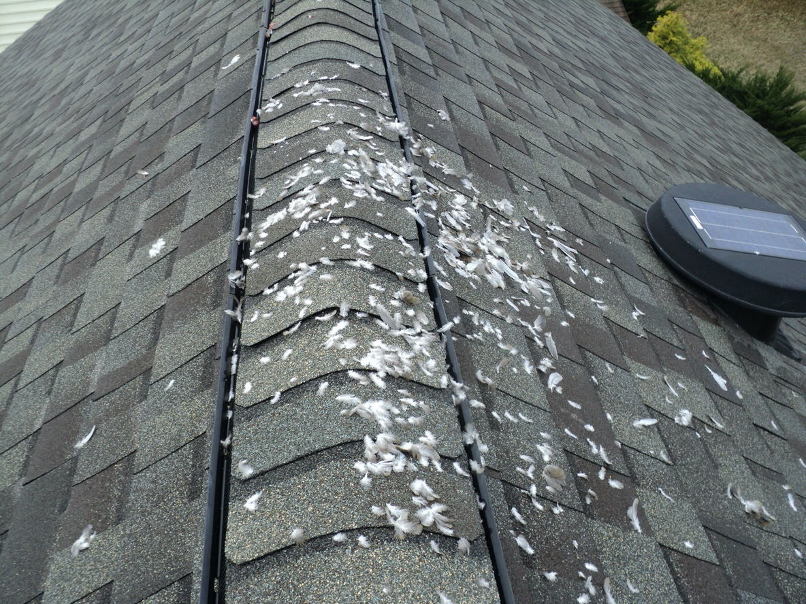

(9)

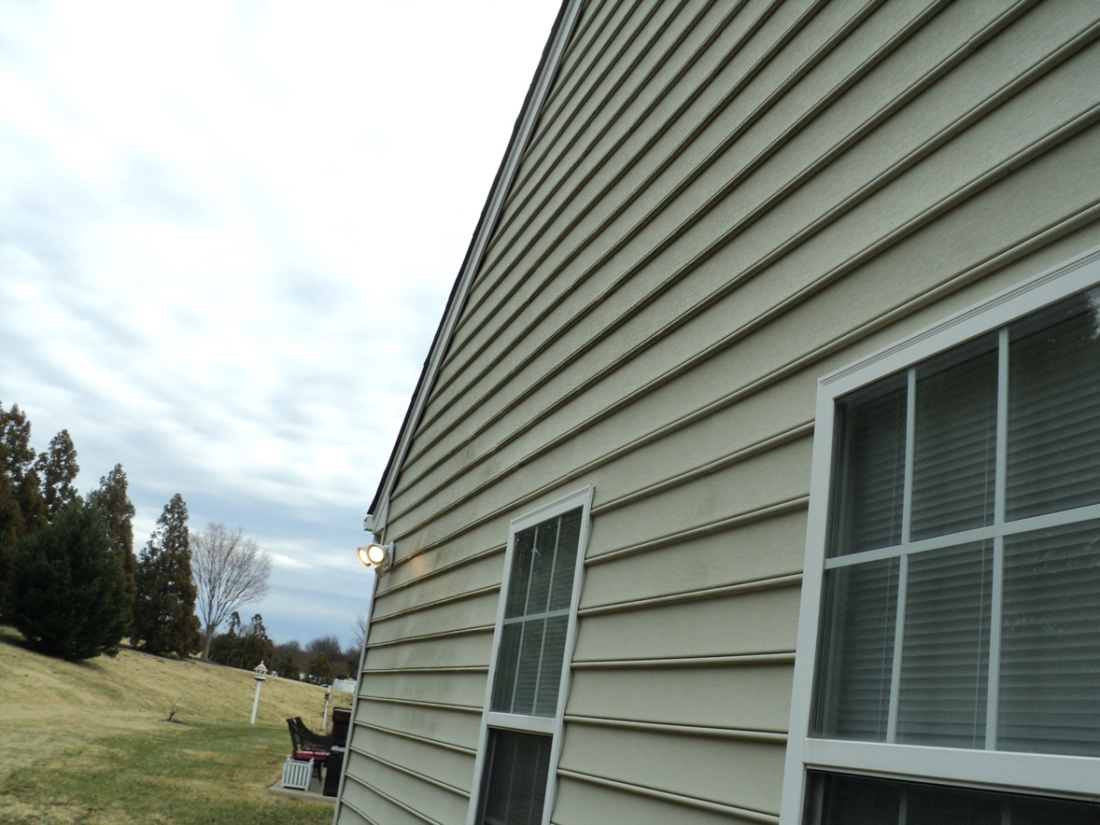

Some of the vinyl siding especially on the back has some surface mold. This can be easily power washed.

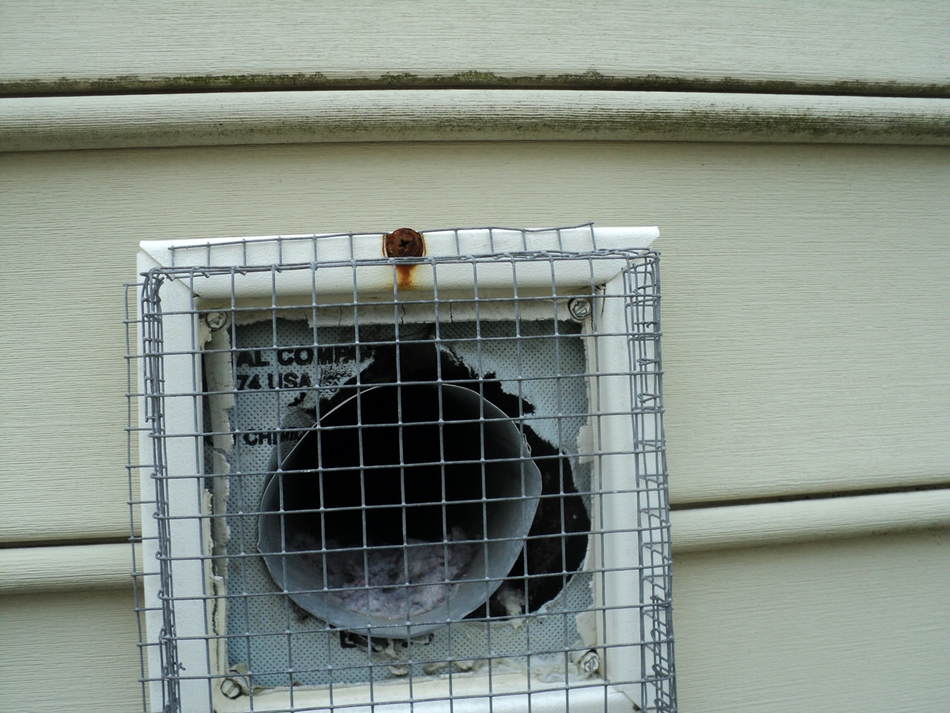

The dryer exhaust vent pipe needs to be cleaned out at the end. A protective cap also needs to be installed to ensure water can not get behind the siding and into living areas. The cap will also prevent birds or bee’s from building nest and restricting air flow.

(10)
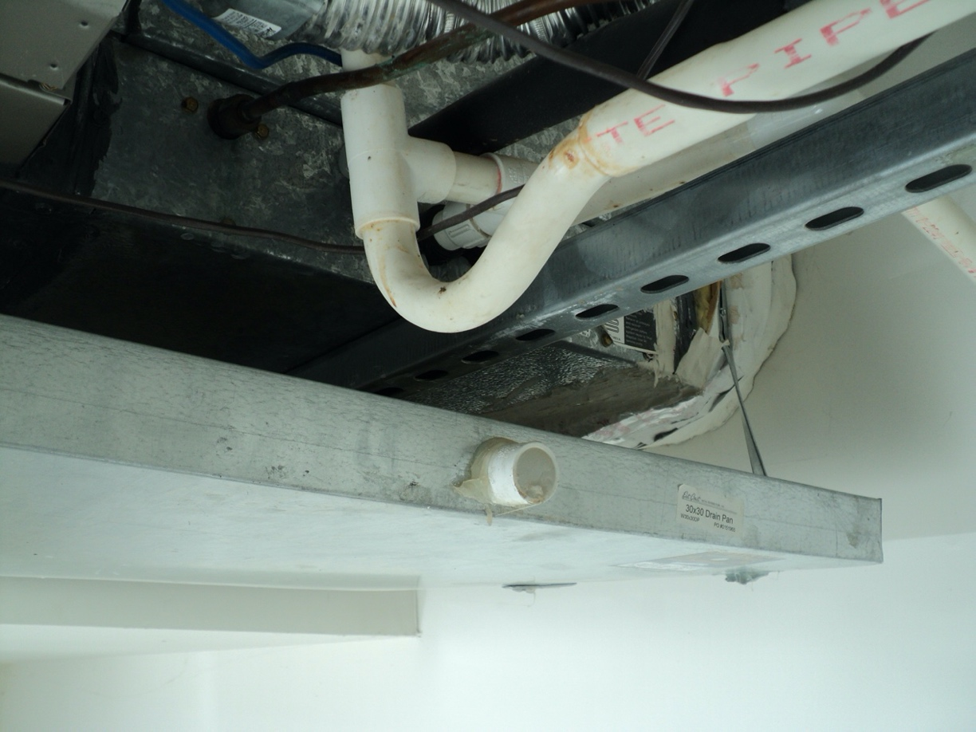

The overflow drain for the overflow pan under the AC unit in the garage ceiling has been capped. This line needs to be connected to a drain line that exits to the exterior of the home.

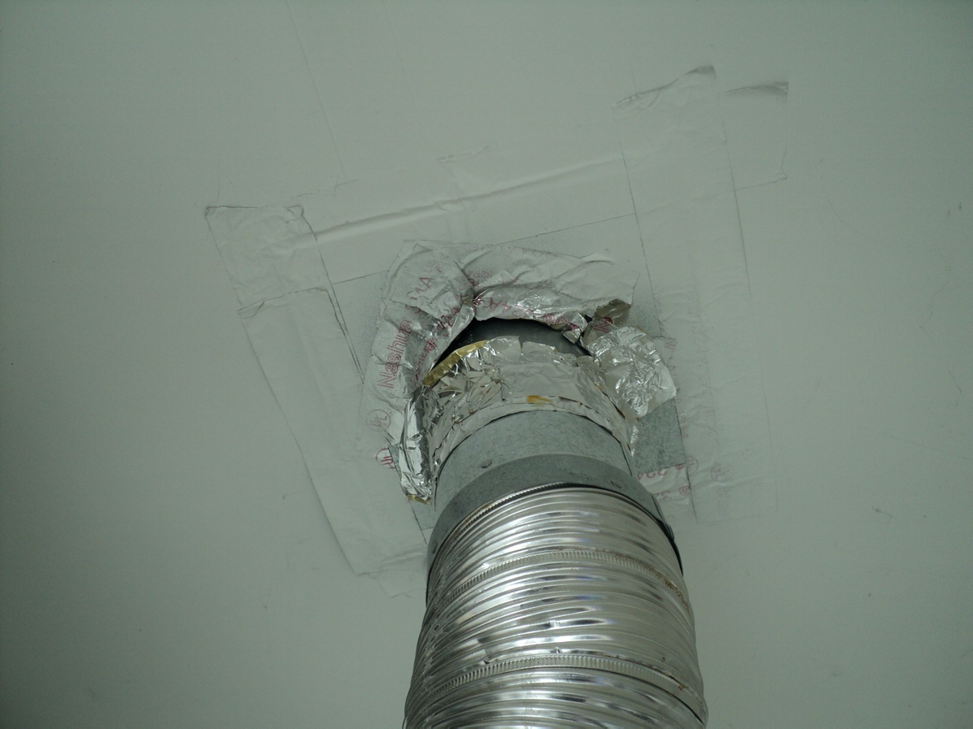

The seal around the exhaust pipe for the water heater and furnace in the garage has come loose and needs to be repaired.

(11)
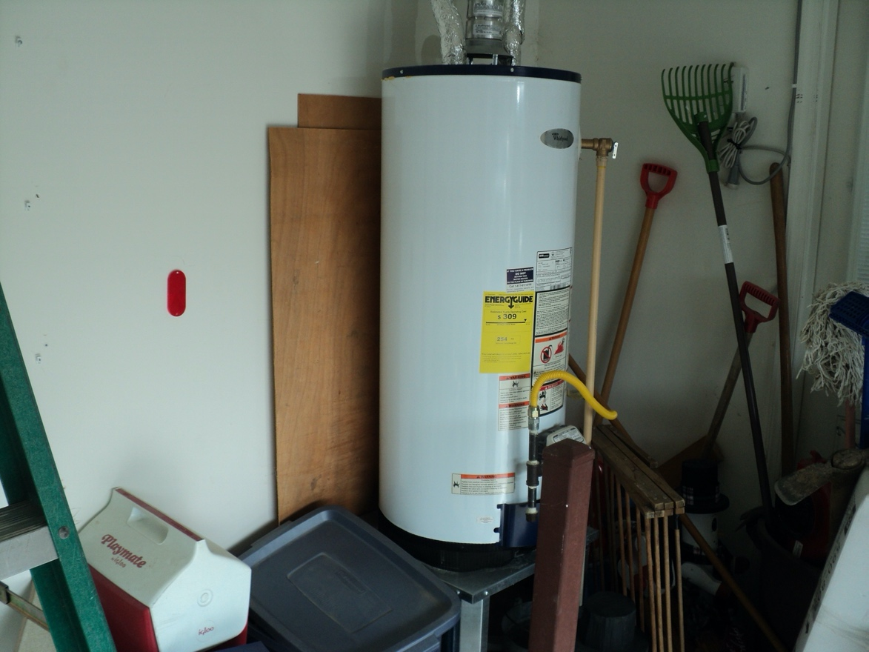
The water heater needs to have a support strap installed to secure the unit to the wall. There is a lot of movemnt in the water heater. With a gas exhaust, the unit needs to be secured.
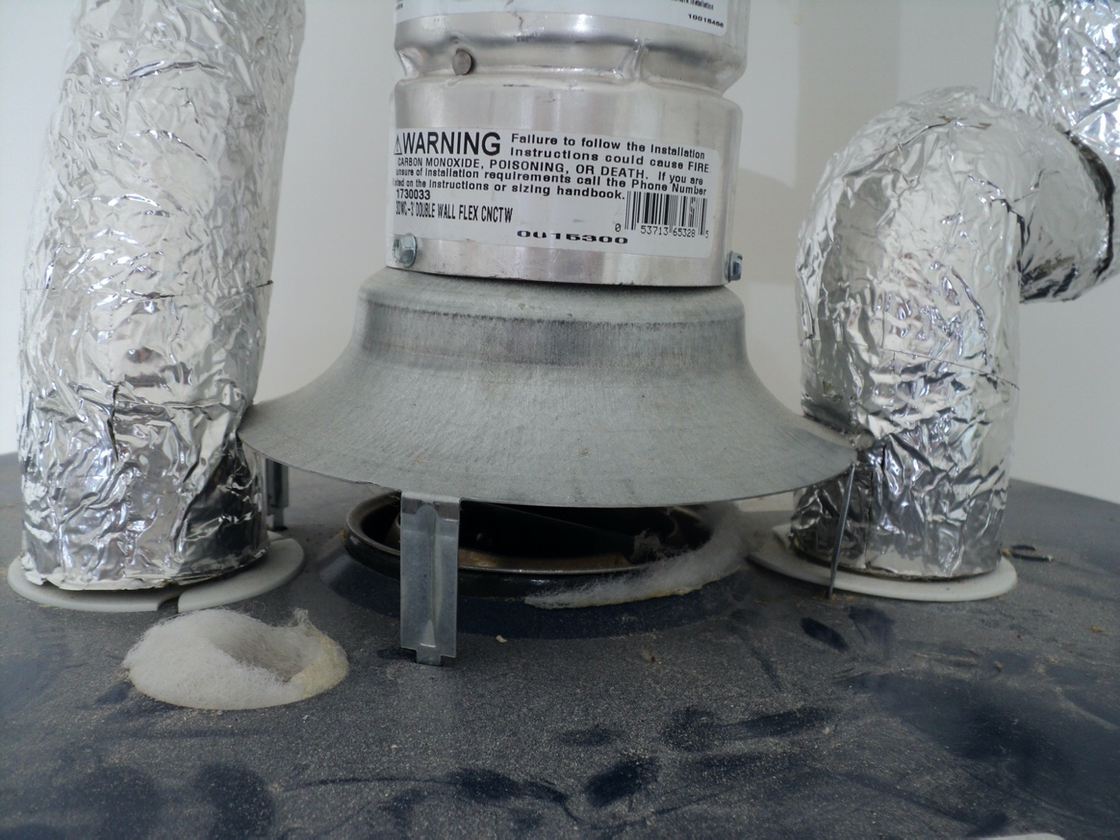
There is a small amout of white insulation around the exhaust for the gas water heater. This insulation is close to the hot exhaust and should be removed.

(12)
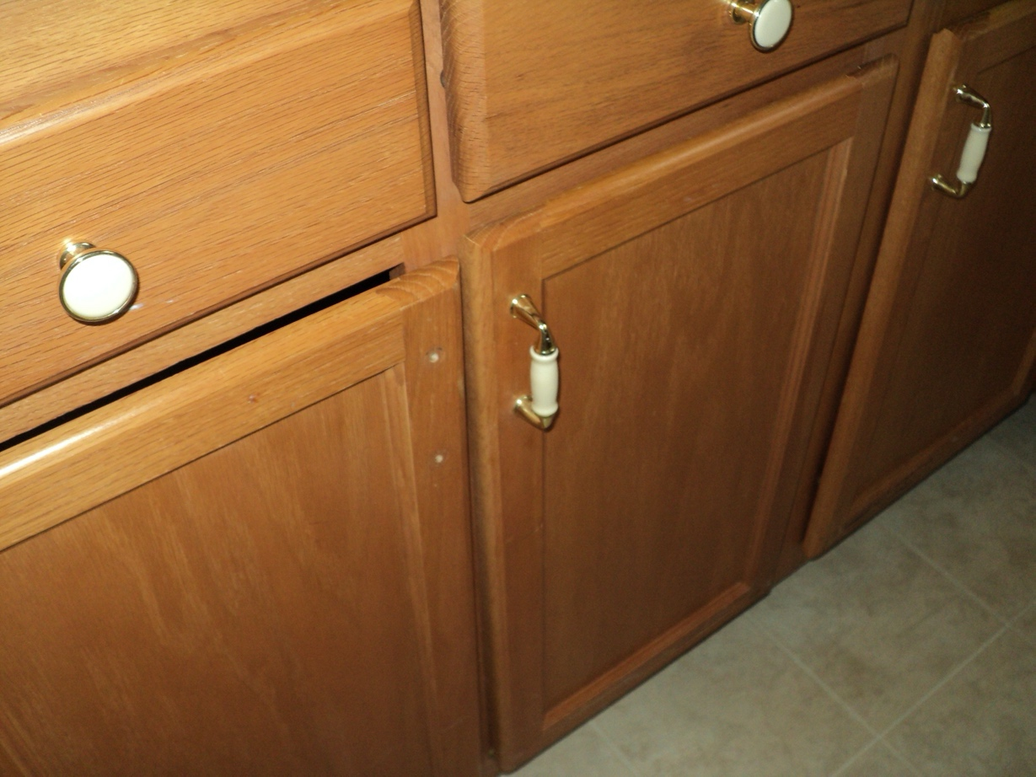
There are a couple cabinets in the kitchen where the matching handles are missing.
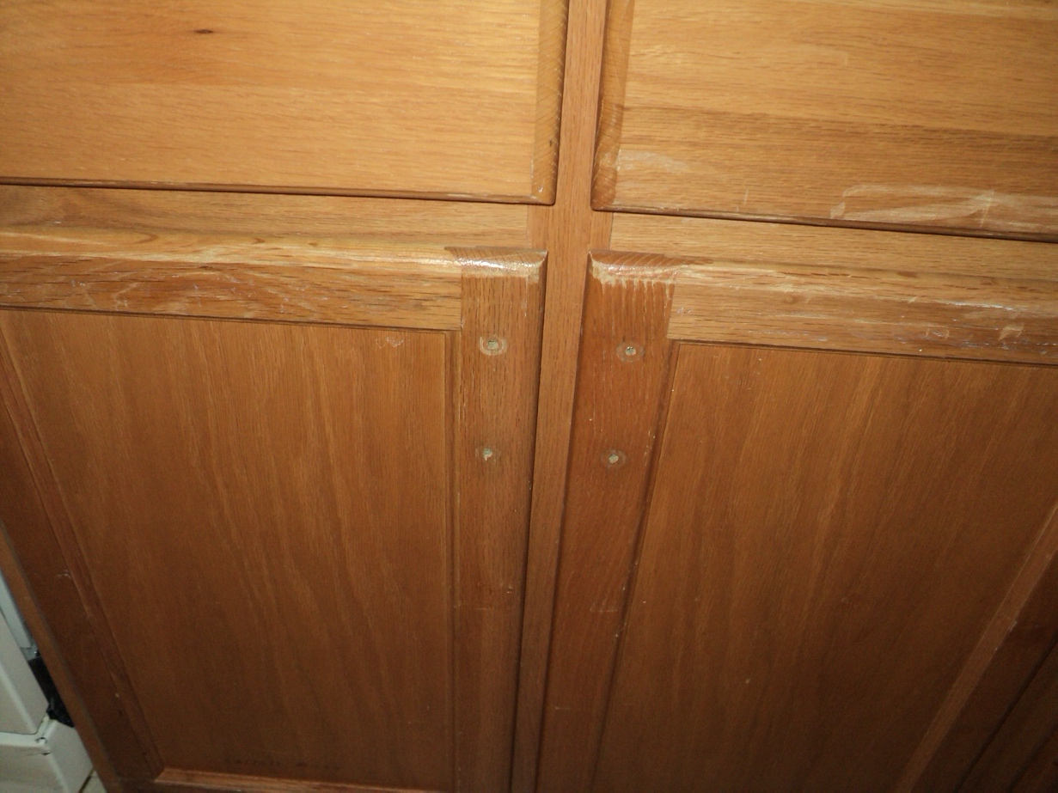

(13)
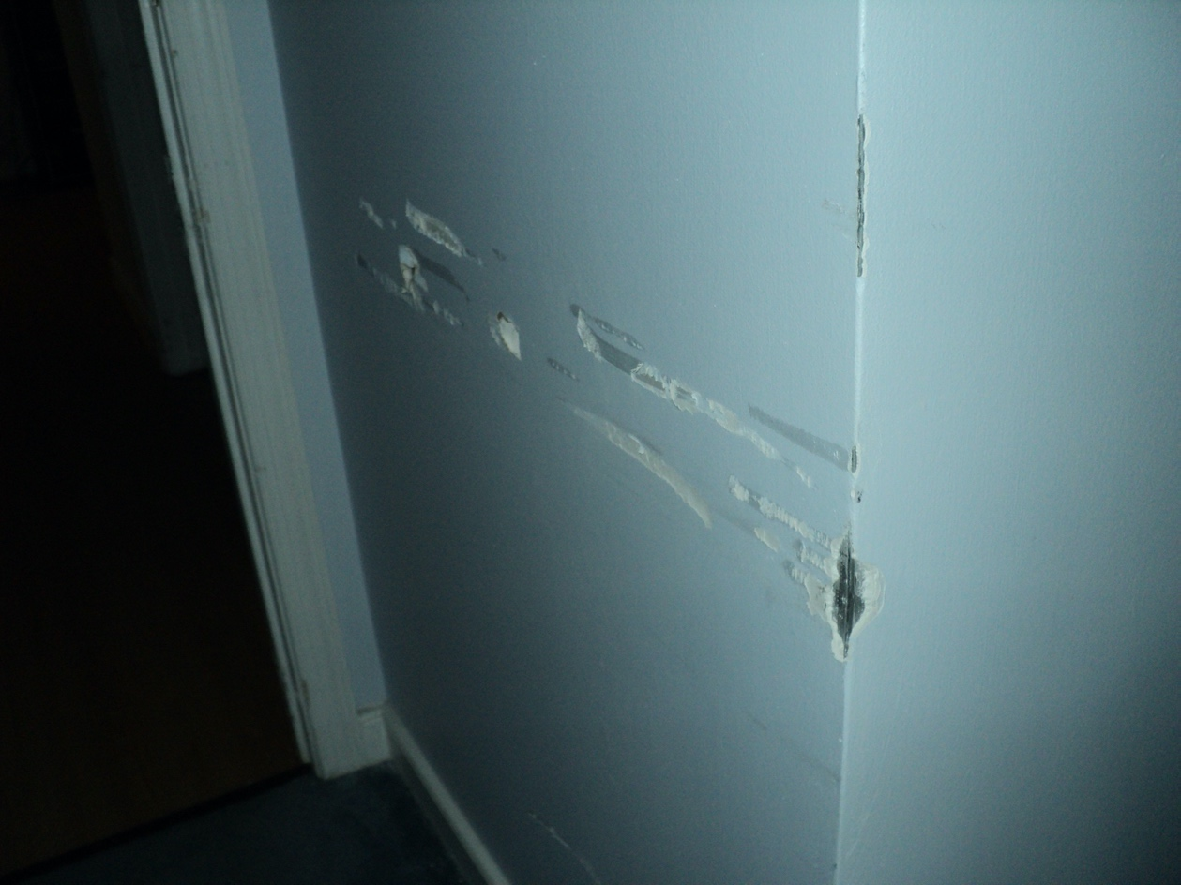

Most of the damage to the interior of the home is to the sheetrock walls, doors and door trim. There is also some small floor damage. Most of this is from the motorized wheelchair and can be repaired.

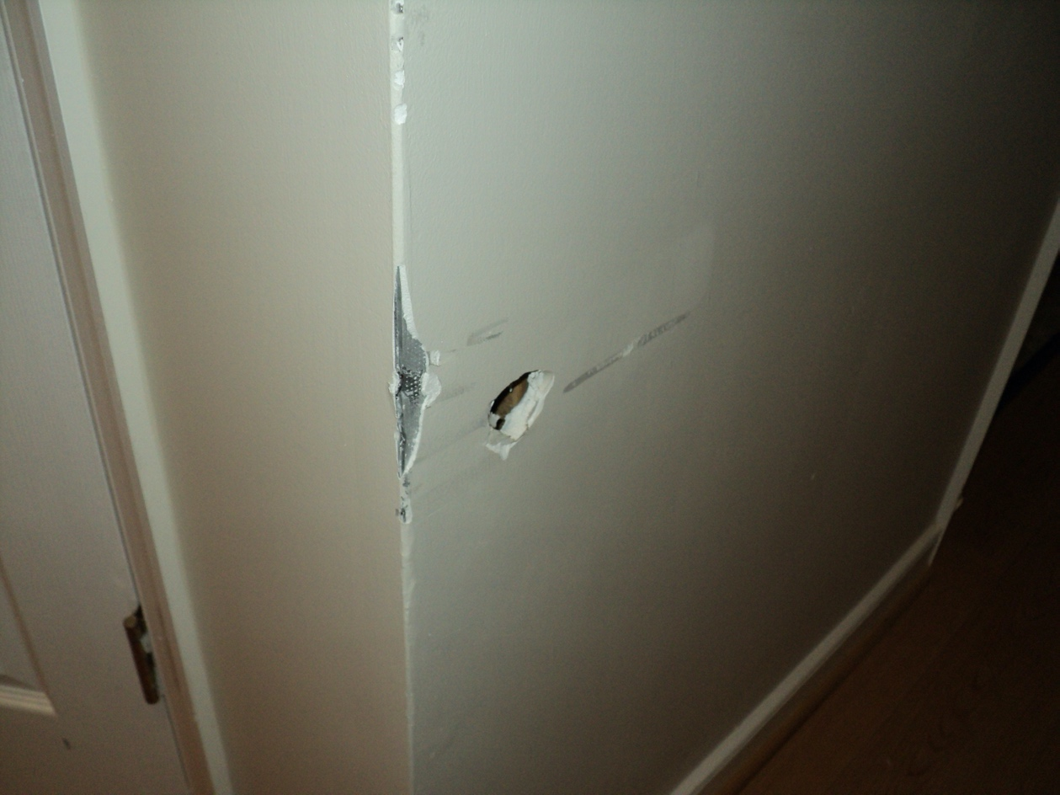

(14)
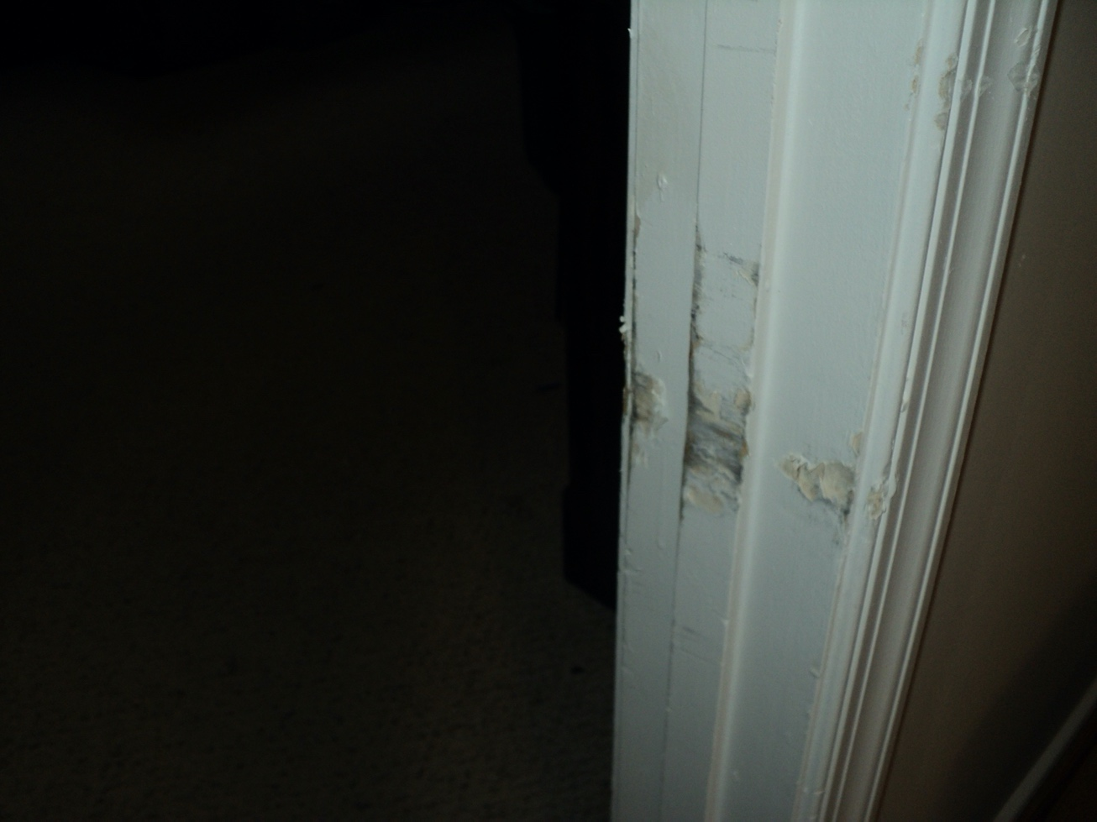

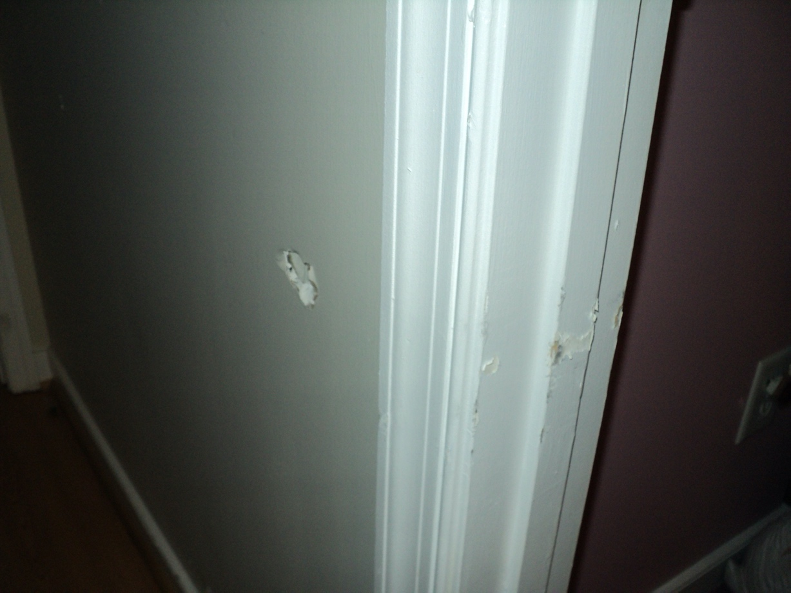

(15)

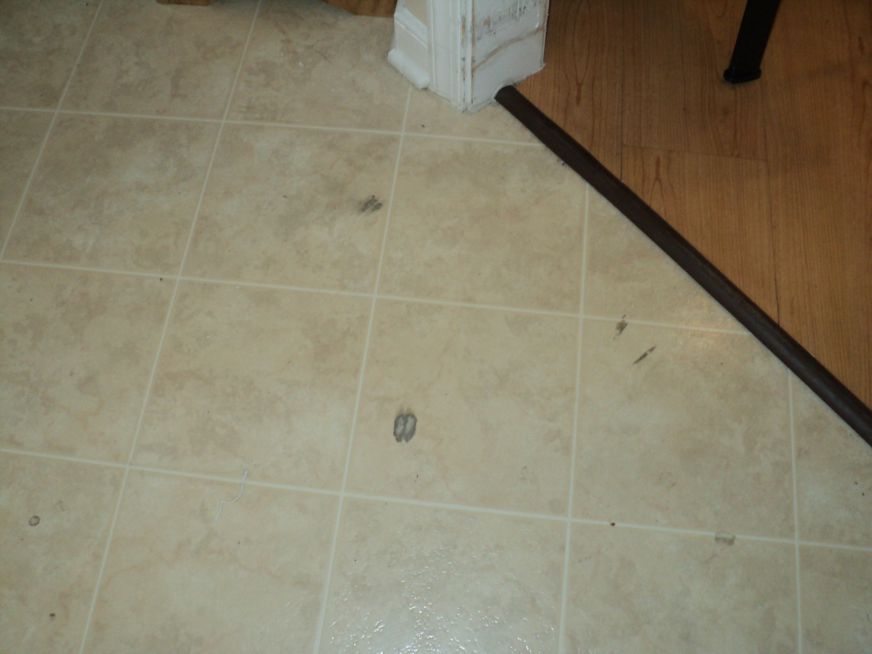

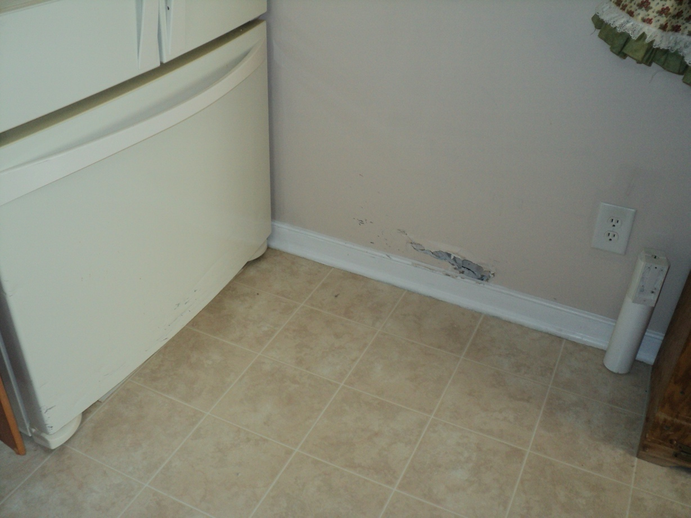

There is also some damage to the freezer drawer in the kitchen.

(16)

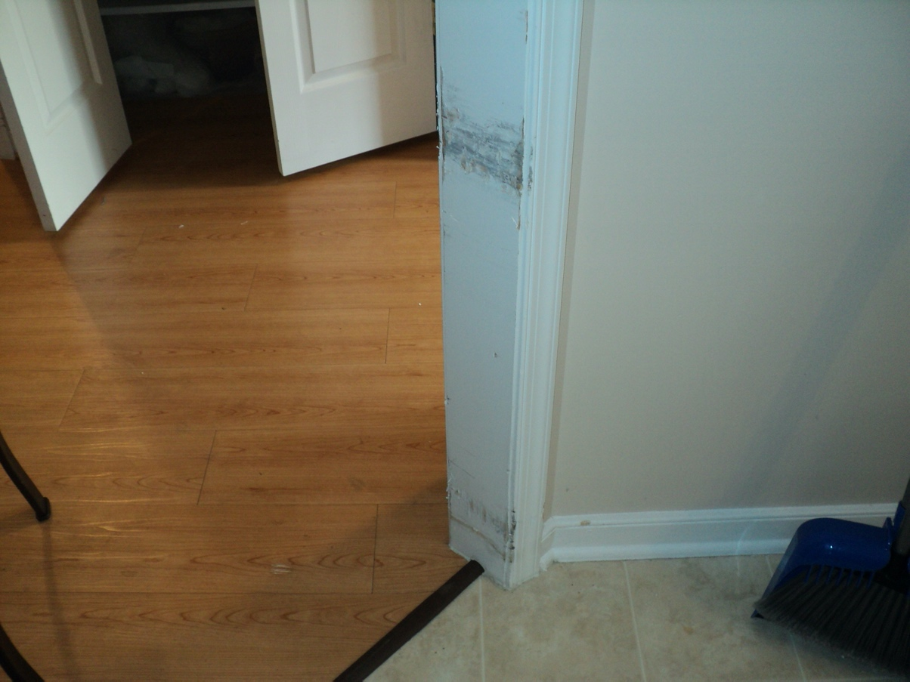

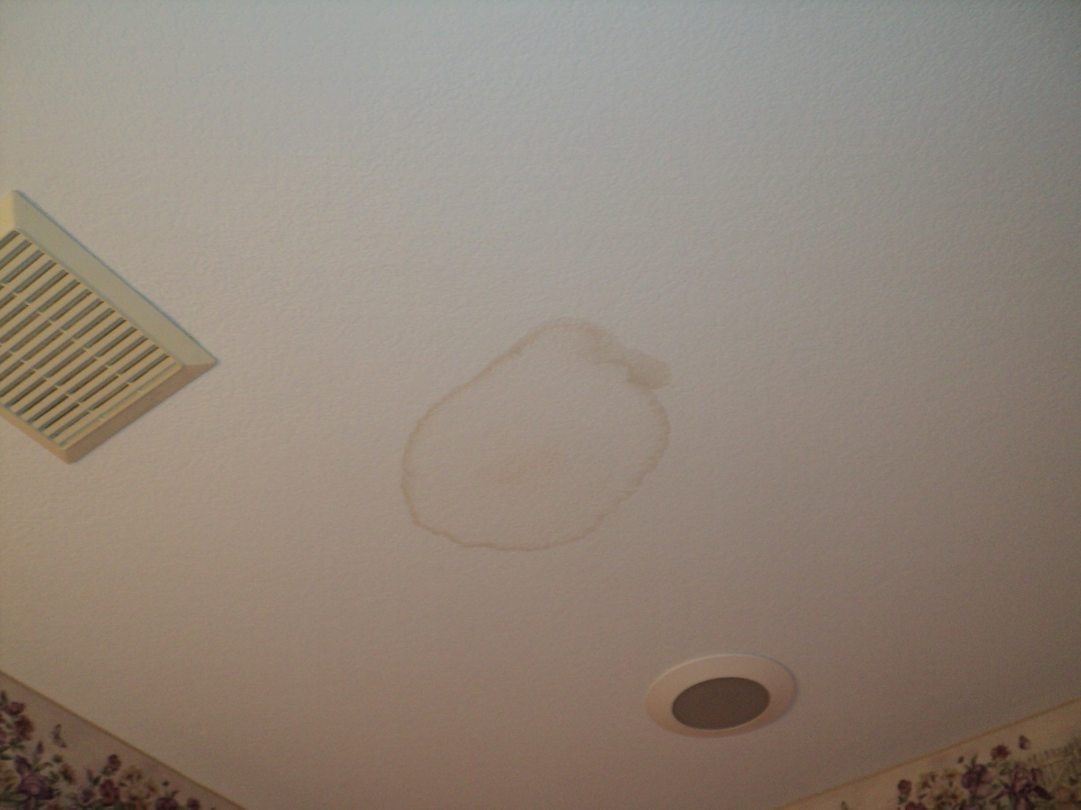

There is a small water stain in the ceiling in the hall bathroom. This is from a leak in the roof that was repaired when the new roof was installed.

(17)
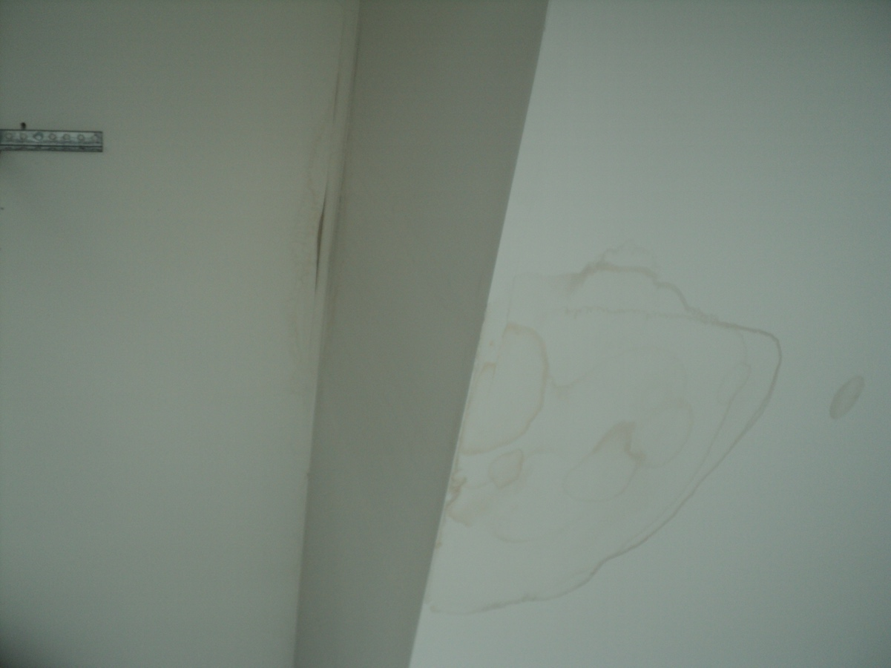

There is a small water stain in the ceiling of the garage. This is from a leak around the exhaust pipe for the water heater and furnace in the roof that was repaired when the new roof was installed. See picture below.

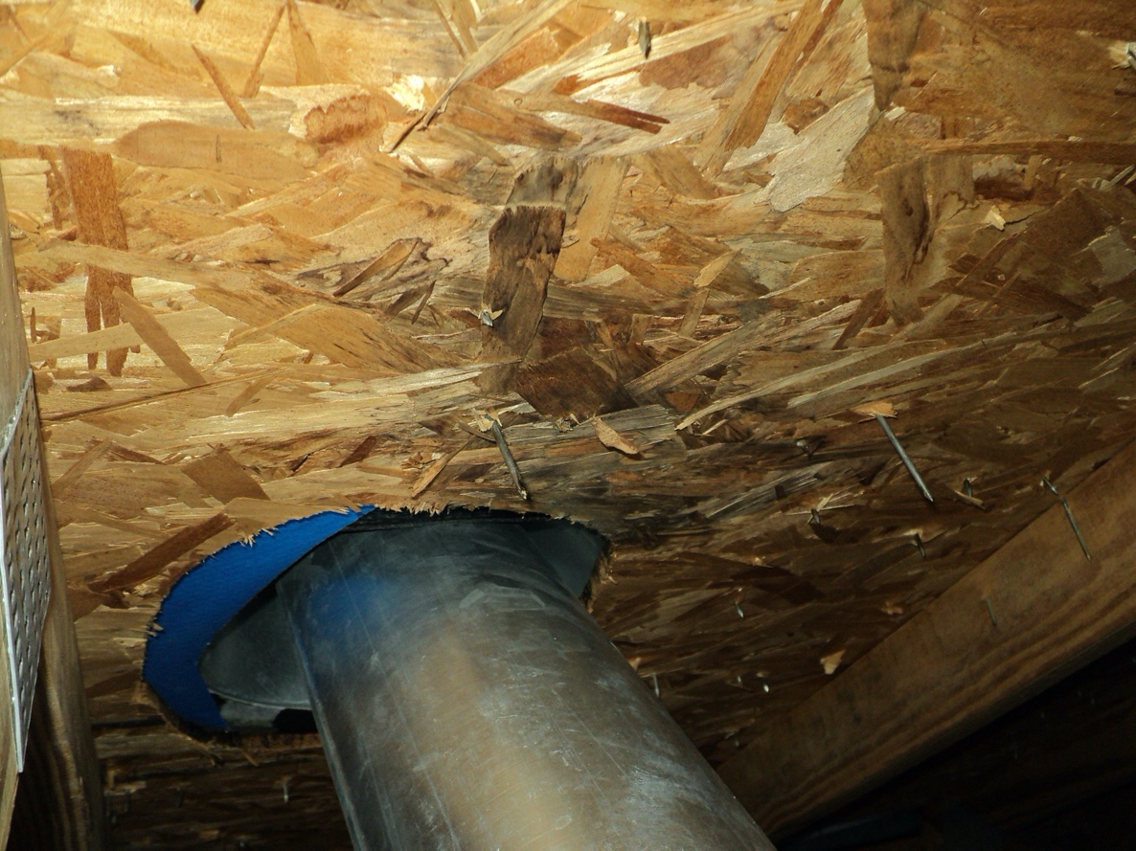

(18)
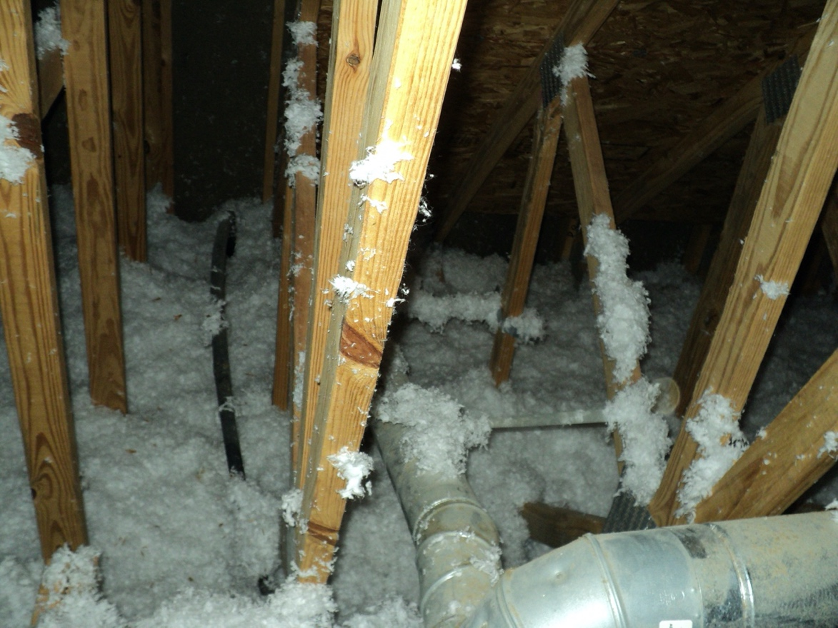

There is blown insulation (installed after the house was established) that is laying on the hot exhaust for the water heater. This insulation should be removed.

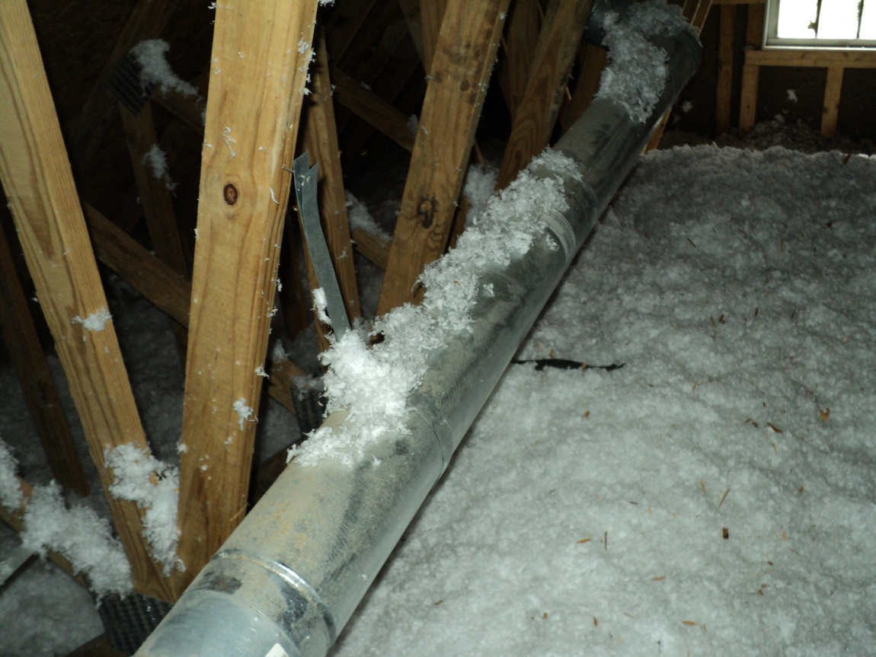

There is blown insulation (installed after the house was established) that is laying on the hot exhaust for the furnance. This insulation should be removed.

(19)
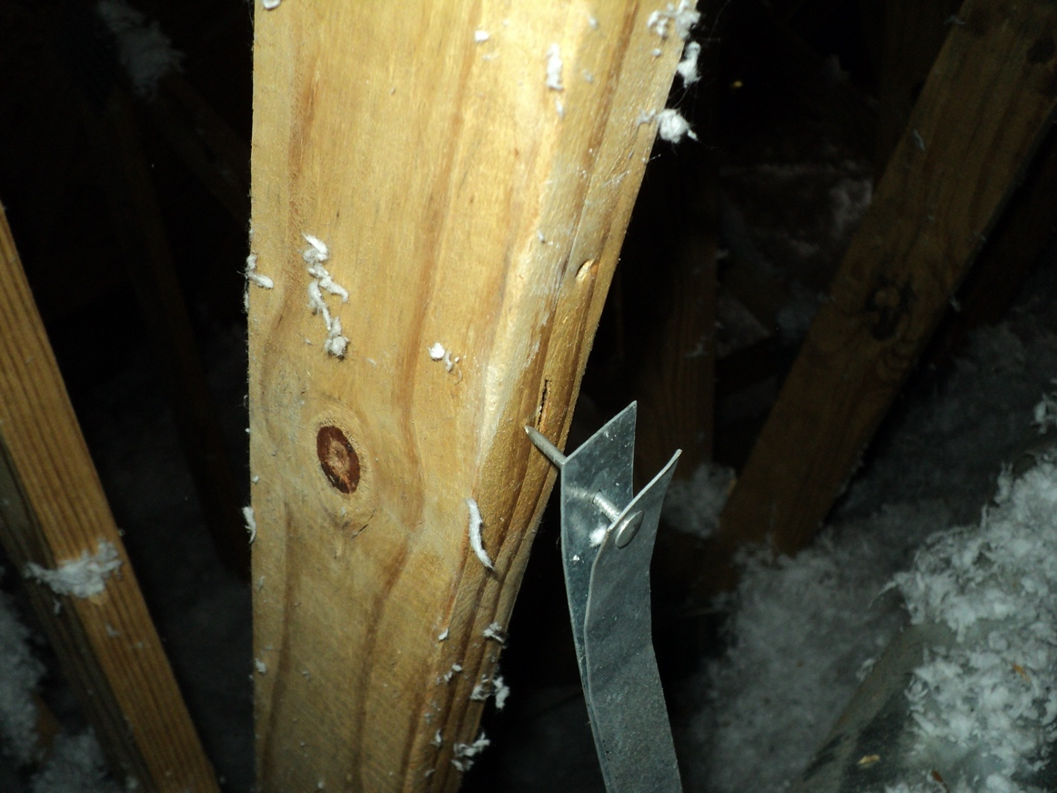

One of the support straps for the exhaust pipe for the furnace in the attic has come loose and needs to be resecured.

(20)
IMPORTANT AGREEMENTS AND LIMITATIONS

SPECIAL NOTE: THE FOLLOWING IS NOT INCLUDED IN THIS INSPECTION: 1. WATER OR
AIR QUALITY 2. PRESENCE OF TOXIC OR CARCINOGENIC MATTER EMITTED FROM THE
GROUND, BUILDING MATERIALS, IN WATER OR AIR SUPPLY OR FROM THE OPERATION OF
ANY EQUIPMENT 3. ITEMS THAT ARE OBSTRUCTED, INACCESSIBLE OR NOT IN PLAIN VIEW. -
The Client is hereby informed structural and mechanical insurance is available for a nominal fee
From insurance companies. Your real estate agent may be able to help you with obtaining structural
Alternatively, mechanical insurance coverage. The client understands that the Comments and Notations made
On this report is subjective opinion of the inspector based on observations at the time of inspection.
Therefore, the INSPECTOR desires it be clearly understood he offers NO WARRANTY concerning
Future operation or condition of any item inspected - OR - that all defects of such items were observed
At the time of inspection and noted on the report. THEREFORE, the INSPECTOR does not imply that
He warrants or guarantees any item regardless of whether they were inspected or reported.

1. What We Do:
a. All inspections are performed in accordance with Standards of Practice. The inspection is of conditions, which are present and visible at the time of the inspection. All mechanical and electrical equipment, systems, and appliances are operated in normal modes and operating range at the time of the inspection.

b. We shall observe, render an opinion, and report which of the parts, components and systems are not functioning at the time of the inspection or need repair and report on visible existing or recognized hazards.
c. If you have questions, we will explain what we saw about the item.

2. What We Do Not Do:
a. We do not make guarantees, warranties, representations, or insure the future performance or condition of any item. If you want a warranty, guarantee, or insurance policy, you must obtain it from a warranty or insurance company. Please remember that almost every item in any used home is in used condition and has ordinary wear and tear, and all houses will change and deteriorate in the future. WE DISCLAIM ALL OTHER WARRANTIES.

b. We do not inspect any item, which we cannot see in a normal inspection. For example, we do not
Move furniture, rugs, carpet, paintings, appliances, or other furnishings in performing an inspection. We do
Not un-cover buried pipes or items. We cannot see items covered by wallpaper, flooring, or plants. Repairs
Alternatively, remodeling may hide evidence of prior damage or defects. We do suggest that you ask the seller about
Repairs that are covered up or any previous problems because we DO NOT report on past conditions that
Appear corrected. We do not inspect for latent defects, therefore, you should obtain a copy of the sellers
Disclosure statement.
c. We do not inspect for building codes, soil analysis, adequacy of design, capacity, efficiency size, value, floor plain location, pollution, habitability, environmental hazards such as asbestos, UFFI, EMF, lead base paint, etc. Please remember older homes do not meet the same standards as newer homes, even though items in both may perform the function for which they are intended.

©Copyright 2001 Housing Inspection Foundation Housing Inspection Form #2700 7/99

(21)

d. We do not allow the inspector to change or add to these printed provisions in any way.

e. We do not hold ourselves to be specialists for any item or engineers. We are a general real
Estate improvement Inspection Company. If we report an item is not performing its intended function, needs repair, or shows evidence of prior damage, we urge you to have that item examined by a specialist before purchasing the house. We do not and cannot give cost estimates to repair any item.

3. What You Must Do:
a. If you have any complaints about our inspection, you must notify us in writing within seven days
After you discovered any problem, and allow us to re-inspect before changing the condition on the item,
Except in an emergency.

b. If we report an item needs immediate repair, or is not performing its intended function or shows
Past damage and you intend to purchase the property anyway; you should first have the item re-inspected by a specialist in that field (i.e., foundation - structural engineer//plumbing - plumber).

c. You agree that, to the extent allowed by law, any damages for breach of this contract or report are limited to the amount of the inspection fee only.

d. If you sue on this inspection, but do not prevail, you agree to pay all our reasonable attorney’s fees.

e. You represent to us that (1) the inspector has not made any oral representations that are different from, or in addition to, what is written in this report, and (2) you agree to each provision of this report by relying on it any way, whether or not you sign it.

f. You shall not allow anyone else to use or rely on this report without prior written consent

THIS REPORT CANNOT AND DOES NOT REPRESENT THE OPERATION OR CONDITION OF ANY ITEM AFTER THE DATE AND TIME OF THIS INSPECTION. ALL WARRANTIES EXPRESSED OR IMPLIED ARE DISCLAIMED.

Dated this 27th Day of December 2021

NAME Jesse Dodd SIGNATURE _________________________________________

REGISTERED HOUSING INSPECTOR #

Copyright 2001 Housing Inspection Foundation Housing Inspection Form #2700 7/99

Housing Inspection Foundation • 1224 North Nokomis NE • Alexandria, Minnesota 56308 USA
Tel: (320)763-6350 • Fax: (320)763-9290 • E-Mail: hif@iami.org • Website: http://www.iami.org

(22)

