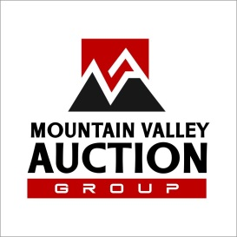  VAF 1028 | Consignment Auction Contract  Fall Consignment Auction  14025 Spotswood Trail, Elkton VA 22827  November 6, 2021 @ 9 AM | VAF 907  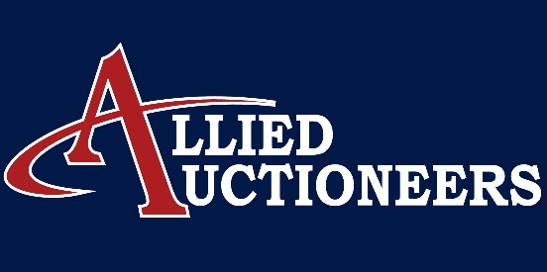

Seller’s Name__________________________________________________________
Address______________________________________________________________
Phone_____________________ Email_____________________________________
This contract sets forth the particulars for which items will be sold via the auction process and describes the obligations and duties of the consignor (Seller) and the auction companies, Allied Auctioneers & Mountain Valley Auction Group. (Auction Company). The Auction Companies are licensed by the VA Dept Occupational Regulation and bonded in favor of the state of Virginia.
1. You the Seller, commission the Auction Company, to sell your items at public auction to the highest bidder. The Seller covenants and agrees that you are the owner, have the right to sell, and all items are free of encumbrances unless disclosed in this contract. Any encumbrances, debts, or fees associated with any item will be satisfied before payment to the Seller. THE SELLER IS NOT PERMITTED TO BID ON THEIR OWN ITEMS.
2. The Auction Company will allow the use of a reasonable, confidential, reserve bid (minimum acceptable selling price) to be placed on certain items. All reserve prices are subject to confirmation of the Seller and Auction Company, and are considered on an individual item basis. Reserve prices that have been agreed upon will be listed on this contact next to the item to which it pertains. The Auction Company reserves the right to sell an item that has NOT reached the reserve price, while committing to a Seller a payoff that would be equivalent to the reserve actually being met. Any items that are not sold will be the Seller’s responsibility to pick up by the first business day following the auction.
3. The Auction Company hereby agrees to use their professional skill, knowledge, and expertise to the best advantage of both parties: the seller and auction company, while preparing for and conducting the auction. The Auction Company reserves the right to group and categorize items into groups or lots at their discretion to affect an advantageous sale. The Auction Company may decline any item that the Auctioneer deems unsuitable for sale.
4. The Auction Company will provide the equipment, materials, and labor necessary to conduct the auction. The Auction Company will also collect auction proceeds and all applicable taxes and disburse all funds to the consignors. The auction company will absorb rental fees for the facility and will provide all advertising for this auction.
5. Terms And Conditions Of The Auction: All items will be sold as-is where is without warranty or guarantee. Auction Company will not be responsible for any representation or warranties made by the Seller. Acceptable payment methods will be cash, good check, and credit card. Online pre-bidding and simulcast bidding will be offered in lieu of absentee bids.
6. Settlement sheets will be made available to the seller at the conclusion of the auction and Settlement will be made no later than thirty (30) days after the date of the auction. All proceeds from the auction will be deposited in escrow account until the time of settlement. The settlement will be disbursed in the form of a check only. If any items remain unpaid or the Auction Company is unable to collect funds for any items sold and not removed from the auction site that item will be returned to the Seller. If any item is sold and removed from the Auction site and subsequently is found to be unpaid for Auction Company will attempt to retrieve that property and return it to the Seller. If unable to be retrieved the Auction Company will pay the Seller for the item after which it becomes the property of the Auction Company if later retrieved.
Commission Rates Are As Follows:
For Items Without Reserve
**ANY SINGLE ITEM $500 OR HIGHER WITH NO RESERVE WILL HAVE NO COMMISSION TO THE SELLER**
Items Selling For Under $500 will have a 20% commission with minimum of $25 total commission per consignor
For Items With Reserve: (No reserve will be permitted on any item for less than $500)
If item sells for $500- $2000 - 10% commission plus a $25 per item consignment fee
If Item sells for $2001- higher 0% commission plus a $50 per item consignment fee
No Sale Fees: 2% of the reserve price or $200 (whichever is less) plus consignment fee will be charged for items that do not meet the reserve. Any items that are not sold will be the sellers responsibility to pick up by the FIRST BUSINESS DAY following the auction.
A 13% buyer’s premium, with a 3% discount for cash and check, will be collected and retained by the auction company as compensation.
Items Consigned
Quantity | Item Description | Reserve Price

8. The consignor/seller agrees to indemnify, defend, and hold harmless Allied Auctioneers and Mountain Valley Auction Group, and its employees, officers, owners, affiliates, agents, and representatives from and against any claims, losses, damages, liabilities, judgments, fees, costs, and expenses, including legal fees and costs, related to, or arising from, or associated with you, your agents, or representatives- including, but not limited to, personal injury or property damage caused at the sale site or during removal or transportation of items consigned for auction.
No Guarantee. Allied Auctioneers and Mountain Valley Auction Group makes no guarantee of any outcome or result from the auction.
This contract contains the complete understanding of all parties involved, and incorporates all prior negotiations, including verbal negotiations. Any modifications to this agreement require written consent of the consignor and Auction Company.
I HAVE READ, UNDERSTAND, AND AGREE TO THIS CONTRACT
Sellers Signature:___________________________________________________________Date:___________________

