COINS
(4) 1999 American Eagle Silver Dollars
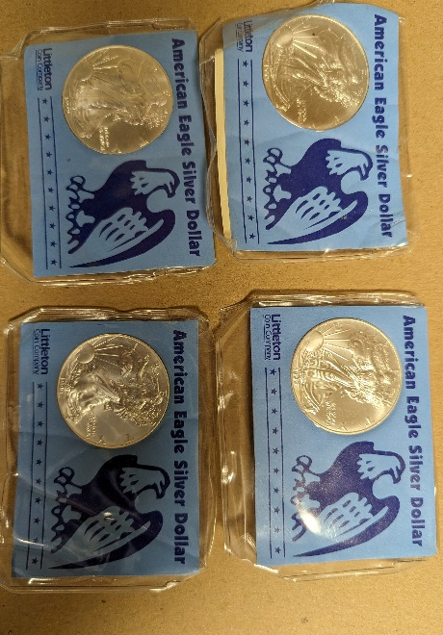 | 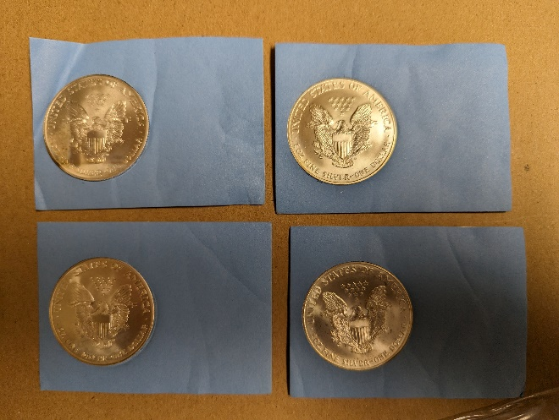

(1) 1829 USA Eagle & Liberty Antique Silver Half Dollar Coin

(1) 1916 20 Plastres Egyptian Coin Silver
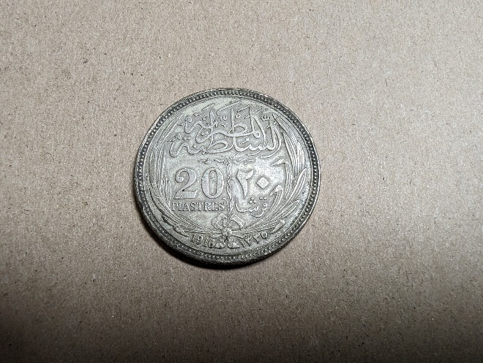 | 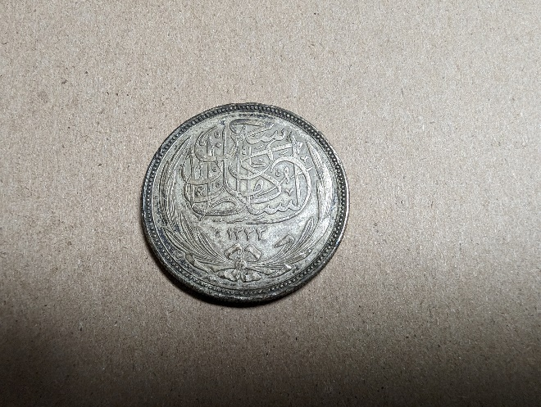

(6) 1921 Morgan Silver Dollars (One w/ Mint Mark S)
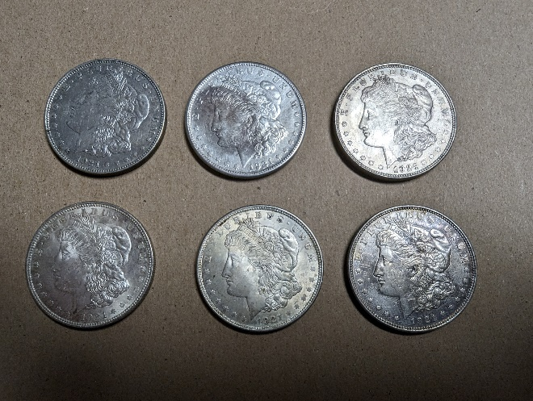 | 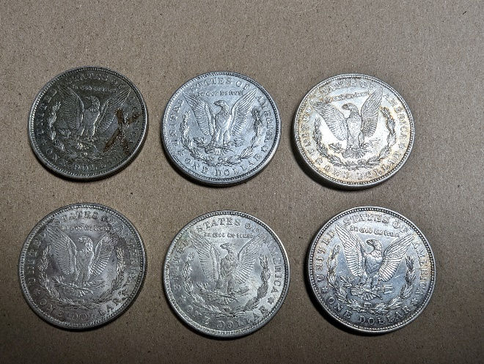

(1) 1852 Liberty Penny
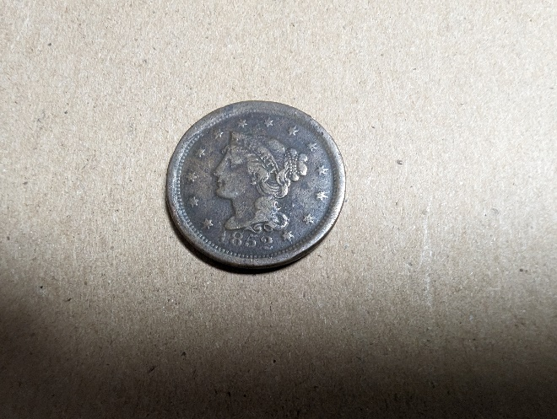 | 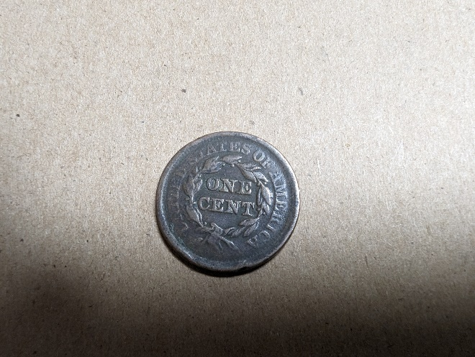

(17) Morgan Silver Dollars: 1880-S, 1884, 1885, 1885, 1886-O, 1887-O, 1888-O, 1889-O, 1889-O, 1890, 1890-O, 1891-O, 1891-O, 1891-O, 1899-O, 1901-O, 1921
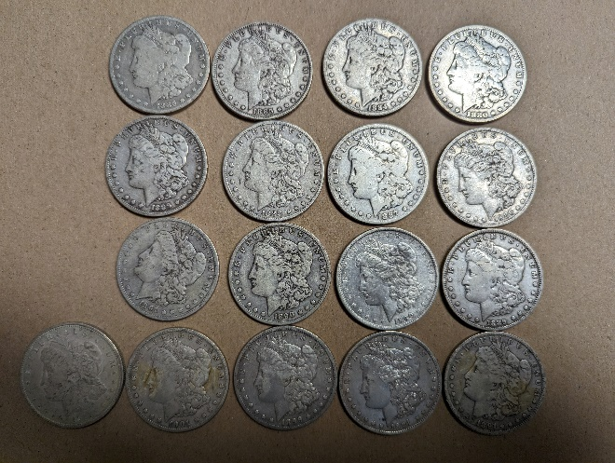 | 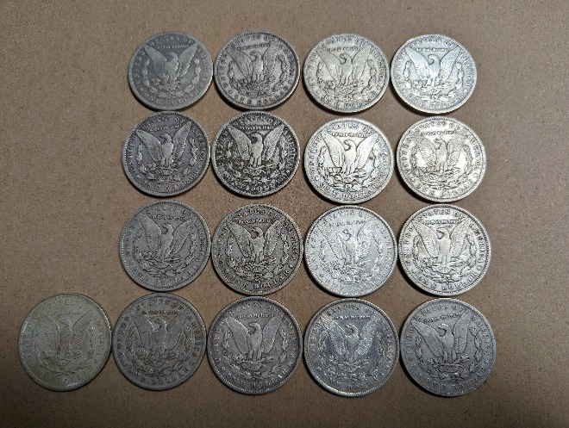

(7) Liberty Peace Dollars: 1923-S, 1924, 1924, 1924, 1924, 1925, 1926
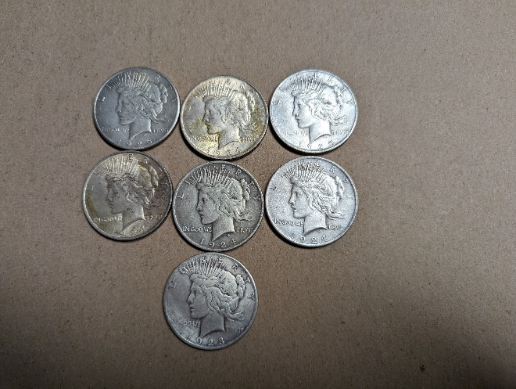 | 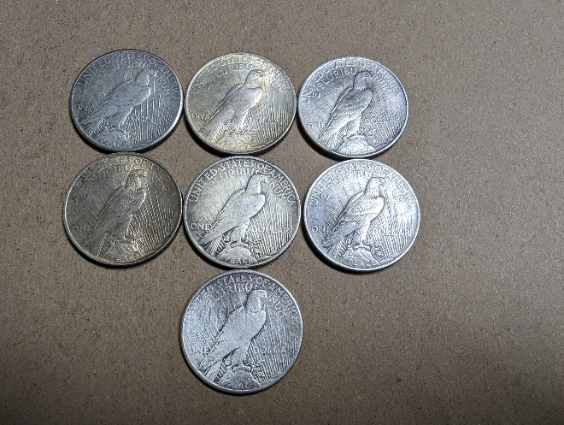

- (16) Kennedy Half Dollars (1960’s) – no photo

(2) Franklin Half Dollars: 1948, 1948
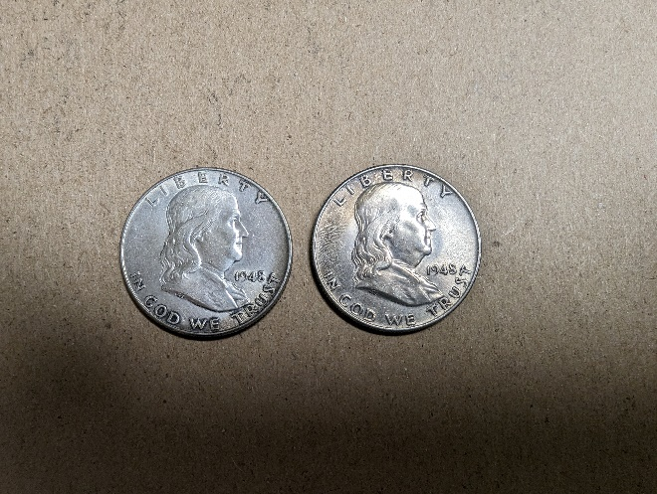 | 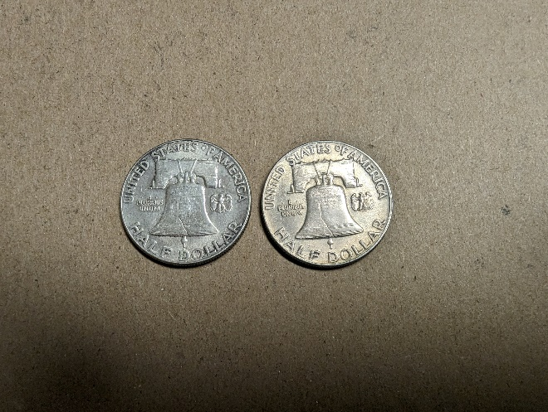

(4) Morgan Silver Dollars: 1879, 1883, 1901, 1921
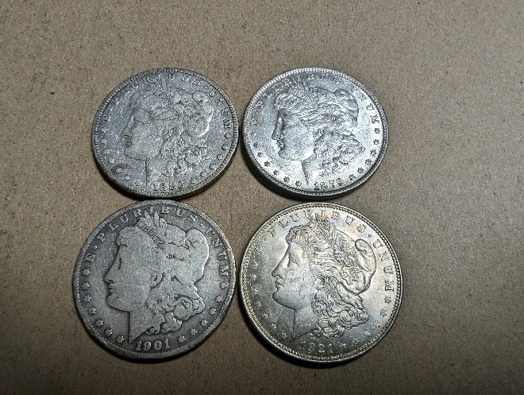 | 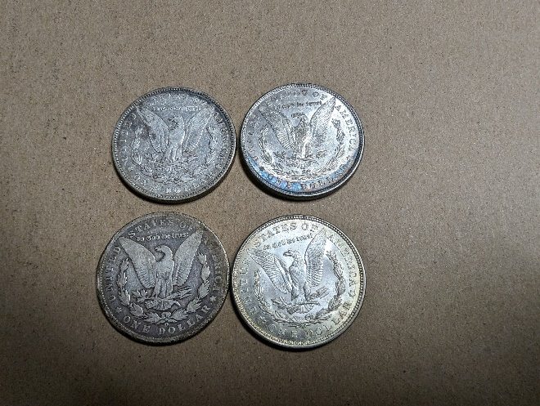

(1) 1894 Morgan Silver Dollar
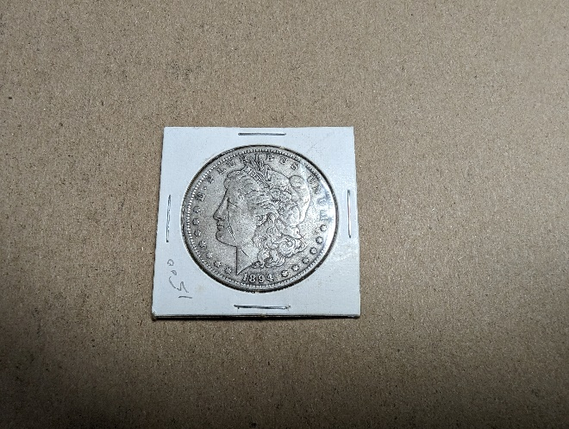 | 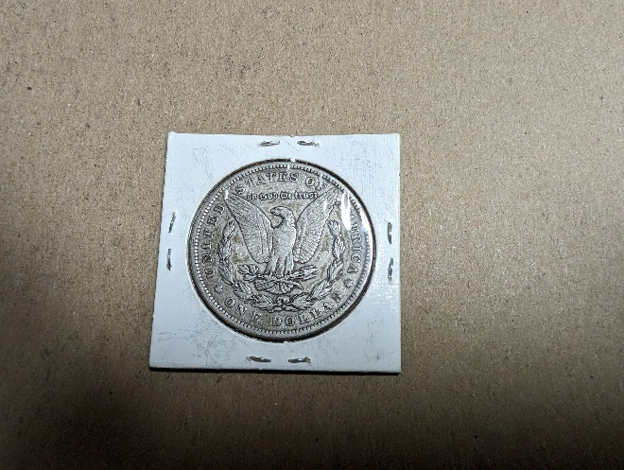

(3) Eisenhower Bicentennial Dollar Coins: (2) Bicentennial, (1) 1972
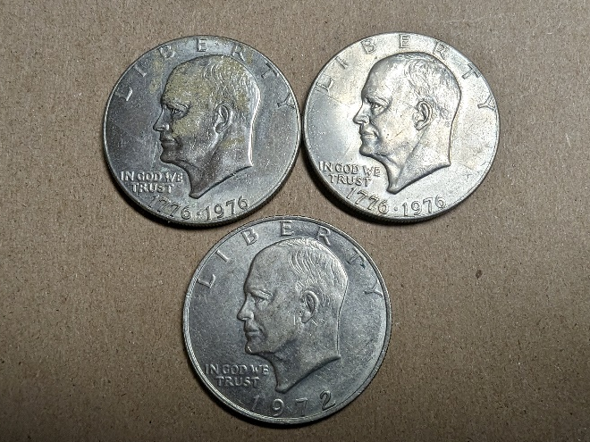 | 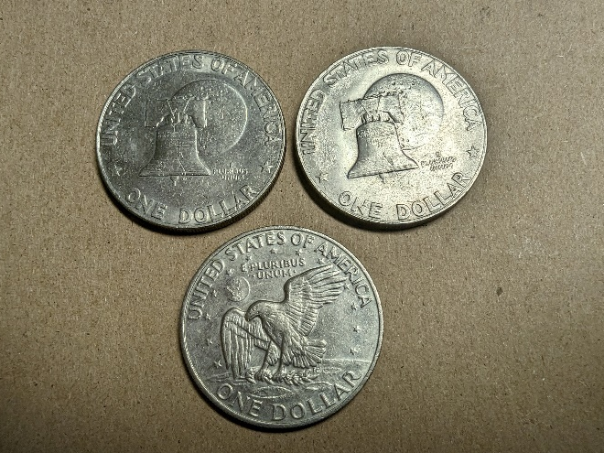

- Bag of Bicentennial Quarters – State Misc. Quarters

(18) Liberty Nickels: 1892, 1910, 1907, 1900, 1911, 1912, 1899, 1907, 1900, 1901, 1892, 1902, 1902, 1910, 1905, 1909, 1901, 1906
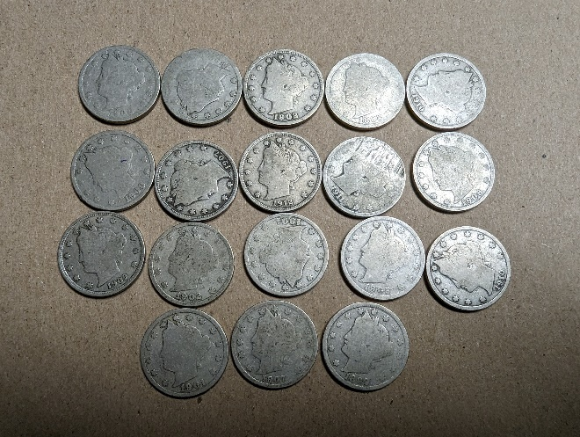 | 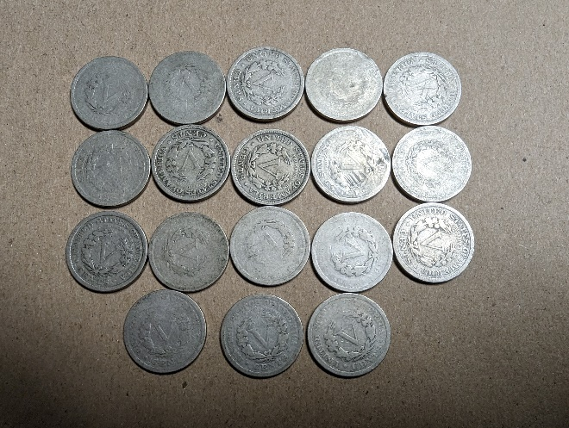

(3) Liberty Dimes: 1901, 1912, 1916
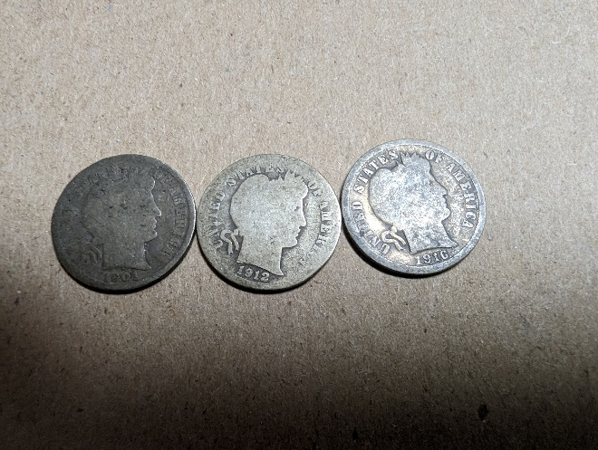 | 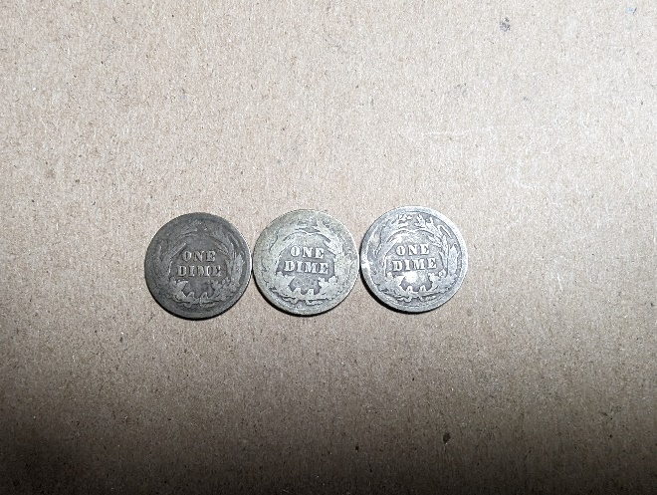

(6) Misc. Susan B. Anthony & President Dollars
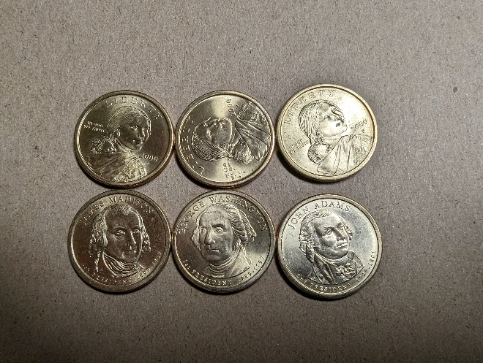 | 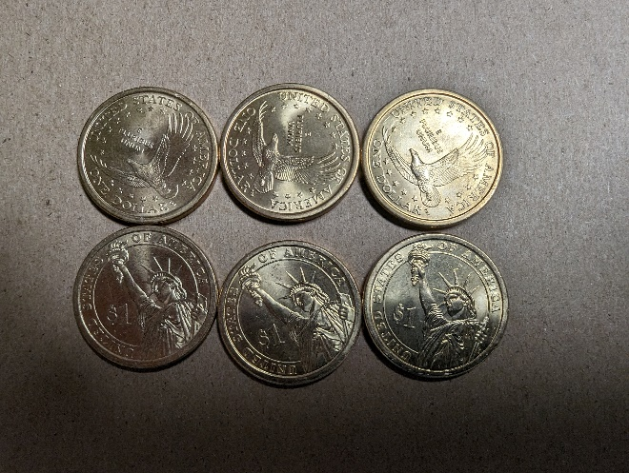

(1) 1918 Mercury Dime; (1) 1986 Indian Head Penny; (1) 1900 Liberty Quarter
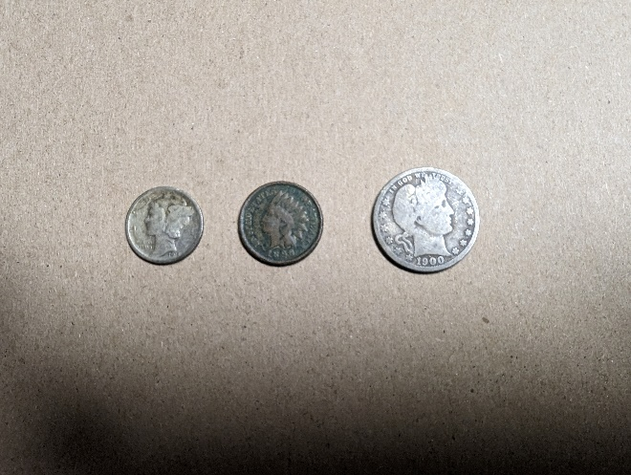 | 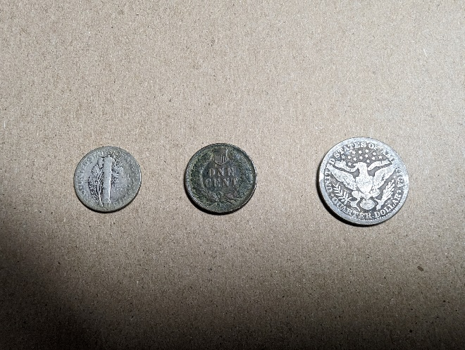
- Bag of Misc. Bicentennial Half Dollars & Quarters
- Misc. Foreign Coins
- Wheat Pennies, Mercury Dimes, Silver Dimes
- Silver Quarters, Wheat Pennies, Mercury Dimes

