**NOTICE OF PUBLIC AUCTION**

# SPECIAL COMMISSIONER’S SALE OF REAL ESTATE

# JAMES CITY COUNTY, VIRGINIA

Pursuant to the terms of those certain Decrees of Sale entered in the Circuit Court of James City County, the undersigned Special Commissioner will offer for sale at public auction the following described real estate in the **James City County Treasurer Board Room**, 101 Mounts Bay Road, Building F, Williamsburg, Virginia 23185, on **Friday, February 21, 2020 at 1:00 pm**, or as soon thereafter as may be effected. The sale of such property is subject to the terms and conditions below and any such terms and conditions which may be announced on the day of the auction. Announcements made on the day of the auction take precedence over any prior written or verbal terms of sale.

|  |  |  |  |
| --- | --- | --- | --- |
|  | **Owner(s) and TACS No.** | **Account Nos.** | **Description** |
| 1. | Bobby Butler, et al.  TACS No. 497232 | Parcel No. 4140600004  LRSN No. 737 | 702 Madison Road, Williamsburg  +/- 0.3 Acre |
| 2. | Daryl & Co., et al.  TACS No. 497254 | Parcel No. 0520500018  LRSN No. 26251 | 9951 Mill Pond Run, Toano  +/- 0.87 Acre |
| 3. | Thomas R. Davidson, et al.  TACS No. 497243 | Parcel No. 1911100046  LRSN No. 1183 | 7602 Beechwood Drive, Lanexa  +/- 0.41 Acre |
| 4. | Julius E. Johnson, et al.  TACS No. 504168 | Parcel No. 2430100048  LRSN No. 16035 | 6423 Centerville Road, Williamsburg  +/- 1.5 Acre |
| 5. | Thelma J. Kendrick, et al.  TACS No. 497230 | Parcel No. 3220100025  LRSN No. 2379 | 222 Clark Lane, Williamsburg  +/- 0.16 Acre |
| 6. | James A. Moir, et al.  TACS No. 497237 | Parcel No. 3240500009  LRSN No. 9088 | 5 Logan Place, Williamsburg  +/- 0.38 Acre |
| 7. | Colette Matilda Sumner  TACS No. 497248 | Parcel No. 3240300010  LRSN No. 17238 | 111 King Henry Way, Williamsburg  +/- 0.26 Acre |
| 8. | Inez Walker, et al.  TACS No. 497233 | Parcel No. 3110500129  LRSN No. 4761 | 202 Mildred Drive, Williamsburg  +/- 0.23 Acre |

TERMS OF SALE: All sales are subject to confirmation by the Circuit Court of James City County. The Special Commissioner of Sale has the right to reject any bids determined to be unreasonable in relation to the estimated value of the Property. The highest bidder shall deposit twenty-five percent (25%) or One Thousand Dollars ($1,000.00), whichever is higher, at the time of the auction. Bids which are less than One Thousand Dollars ($1,000.00) shall be paid in full at the time of the auction. Deposits shall not exceed Twenty Thousand Dollars ($20,000.00). Such sum shall be held by the Special Commissioner and credited towards the purchase price following confirmation of the sale. All deposits must be made in the form of personal check, traveler’s check, cashier’s check or money order. NO CASH WILL BE ACCEPTED. **There will be a 10% buyer’s premium added to the final bid to determine final contract price. The buyer’s premium is due at the time of the auction.**

The balance of the purchase priced shall be deposited by the highest bidder with the Special Commissioner within fifteen (15) days of confirmation of the sale by the Court. **Recording costs for deed recordation will be the responsibility of the successful bidder and will be due with the balance of the purchase price within fifteen (15) days of confirmation of sale by the Court.** Properties are conveyed by Special Warranty Deed, subject to any easements, covenants, agreements, restrictions, reservations, and any and all rights of record which may affect the property.

All properties are sold in gross and not by the acre. Properties are offered for sale as-is, with all faults and without any warranty, either expressed or implied. Persons are encouraged to make a visual inspection of the property within the limits of the law and to obtain an independent title search prior to bidding on any of the properties. Bidders are strongly encouraged to make their own inspection to determine the suitableness of the property and it is assumed that all bidders will perform due diligence prior to the day of the auction. Any costs incurred by the bidder to inspect the property are at the expense of the bidder and are non-refundable.

Please be advised that in order to qualify as a purchaser at this auction, you may not owe delinquent taxes to James City County and you may not be a Defendant in any pending delinquent tax matter. Questions concerning the properties subject to sale or the tax sale process should be directed to TACS online at [www.taxva.com](http://www.taxva.com), by email to [taxsales@taxva.com](mailto:taxsales@taxva.com), or by phone to (804) 223-8449, or by writing to the address below.

John A. Rife, Esq., Jeffrey A. Scharf, Esq., Andrew M. Neville, Esq.,

Mark K. Ames, Esq., Gregory L. Haynes, Esq.

Special Commissioners

Taxing Authority Consulting Services, PC

P.O. Box 31800

Henrico, Virginia 23294-1800

**PURCHASER’S ACKNOWLEDGEMENT AND**

**CONTRACT OF SALE**

At that certain Special Commissioner’s sale held on Wednesday, February 21, 2020 in the cause styled James City County v. ___________________ **(Case No. CL_______)**, the undersigned was the highest bidder on the real estate described below, for a bid price of $_____________, and a buyer’s premium of $_____________.

**Tax Map No. _______________________**

**Account No. _______________________**

I understand that a deposit of $_________________ (25% of the purchase price or $1,000.00, whichever is more, not to exceed $20,000.00, or the entire purchase price if less than $1,000.00) is required to be deposited today with the Special Commissioner and that the balance will be due within fifteen (15) days after confirmation of this sale by the Circuit Court of James City County, Virginia. Further, I understand that a 10% buyer’s premium is required in this auction and have agreed to pay $_______________ as a buyer’s premium.

I understand that this property is being sold subject to any covenants, easements, agreements, restrictions, reservations, conditions of record, and any claims of persons in possession. I understand that this property may not have a right-of-way to a public road, and I hereby accept this limitation. I understand that I will be notified at the address below of the date the Court intends to confirm this sale, and that this Court hearing will be my last opportunity to raise any questions concerning this sale. I understand that this property is offered for sale as-is, with all faults and without any warranty, either expressed or implied, and I confirm that I have satisfied myself as to the property’s existence and location prior to the execution of this contract.

I understand that I will be responsible for any real estate taxes on this parcel from the date of sale (auction date). I further understand that in the event I owe delinquent taxes to James City County, or if I am named as a Defendant in any delinquent tax matter, that this contract may be made null and void and I agree to forfeit any right, title or interest that I may have in the real estate to the next highest bidder as listed in the auction documents.

If the balance of the purchase price is not paid in full within fifteen (15) days of confirmation, I agree to forfeit the deposit and buyer’s premium and pay any charges incurred by the Special Commissioner or the Court in collecting on the delinquent amount. I further understand that if I fail to comply with this Purchaser’s Acknowledgement and Contract of Sale, that this real estate may be resold and that I will be responsible for any deficiency upon resale, including any expenses that may be incurred.

I understand that the former owner(s) of this property may for good cause shown, within ninety (90) days from the entry of the Decree of Confirmation in this matter, petition the Court to have the matter reheard. I understand that title to the property described herein will be taken in the name(s) indicated below and I represent that I have the authority to purchase and title the property in the name(s) shown below.

|  |  |
| --- | --- |
|  |  |
|  | Signature  ______________________________________ |
|  | Print Name  ______________________________________ |
|  | Address  ______________________________________ |
|  | Phone  ______________________________________ |
|  | Email |

Title will be taken in the name of:

**______________________________________________________________________________**

Type of Interest: □ Tenants in Common □ Tenants by Entirety with ROS □ Joint Tenants □ None

**CERTIFICATION**

It is hereby certified that the above-referenced purchaser has, on this 21st day of February 2020, acknowledged and executed the foregoing Purchaser’s Acknowledgment and Contract of Sale. I further certify that the contact information and signature shown above belong to the aforementioned purchaser and are true and correct to the best of my knowledge.

____________________________________

Taxing Authority Consulting Services, PC

**NOTES**

______________________________________________________________________________________________________________________________________________________________________________________________________________________________________________________________________________________________________________________________________________________________________________________________________________________________________________________________________________________________________________________________________________________________________________________________________________________________________________________________________________________________________________________________________________________________________________________________________________________________________________________________________________________________________________________________________________________________________________________________________________________________________________________________________________________________________________________________________________________________________________________________________________________________________________________________________________________________________________________________________________________________________________________________________________________________________________________________________________________________________________________________________________________________________________________________________________________________________________________________________________________________________________________________________________________________________________________________________________________________________________________________________________________________________________________________________________________________________________________________________________________________________________________________________________________________________________________________________________________________________________________________________________________________________________________________________________________________________________________________________________________________________________________________________________________________________________________________________________________________________________________________________________________________________________________________________________________________________________________________________________________________________________________________________________________________________________________________________________________________________________________________________________________________________

**Parcel 1: Bobby Butler, et al**

**Parcel No. 4140600004**

**LRSN No. 737**

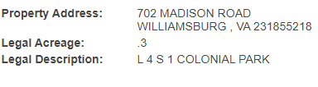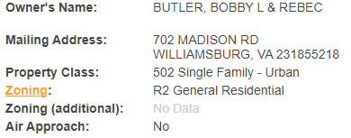

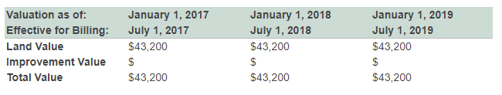

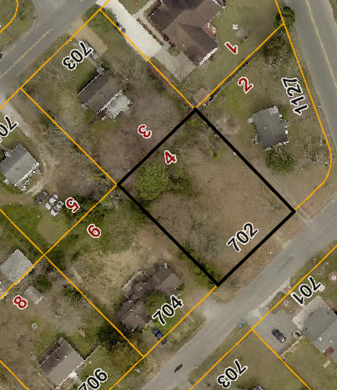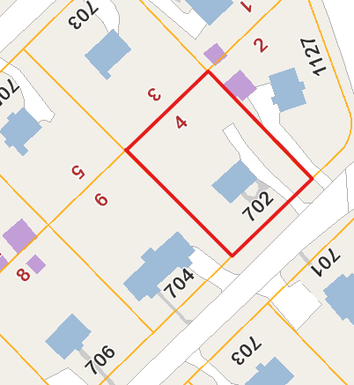

**Parcel 2: Daryl & Co., et al**

**Parcel No. 0520500018**

**LRSN No. 26251**

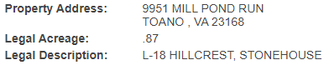

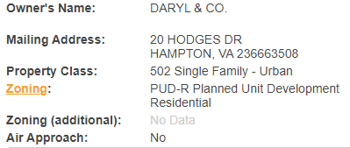

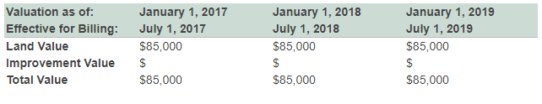

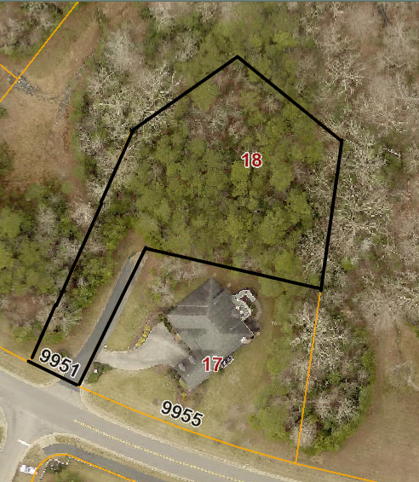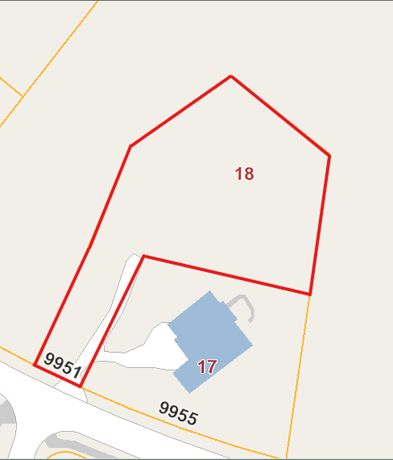

**Parcel 3: Thomas R. Davidson, et al.**

**Parcel No. 1911100046**

**LRSN No. 1183**

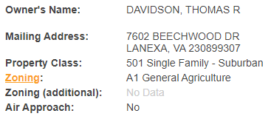

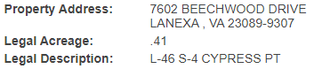

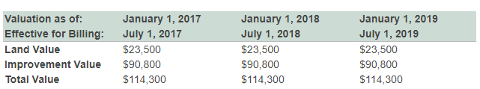

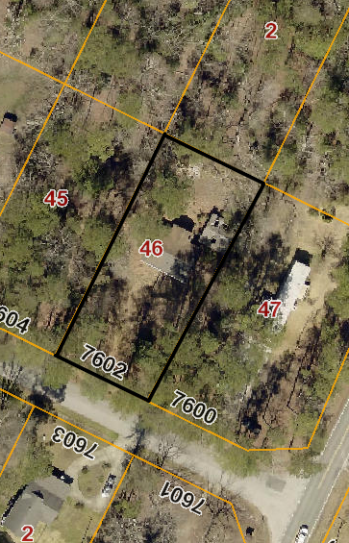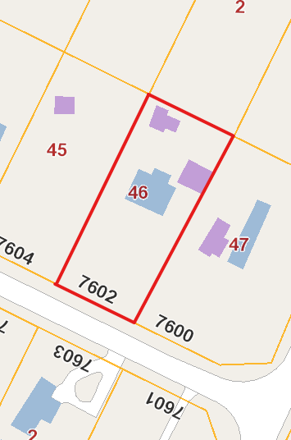

**Parcel 4: Julius E. Johnson, et al.**

**Parcel No. 2430100048**

**LRSN No. 16035**

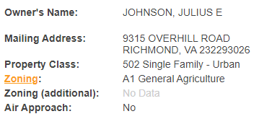

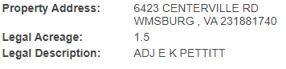

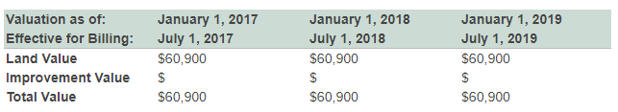

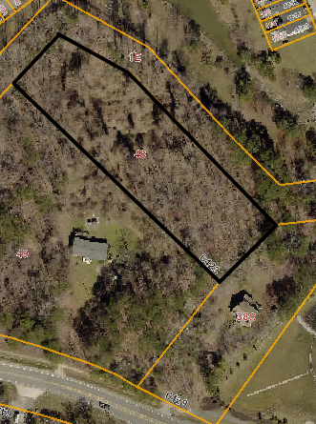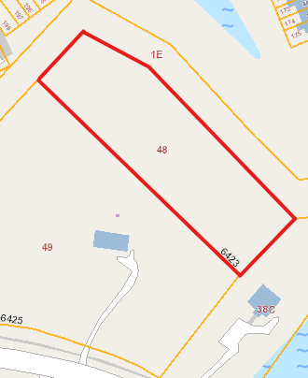

**Parcel 5: Thelma J. Kendrick, et al.**

**Parcel No. 3220100025**

**LRSN No. 2379**

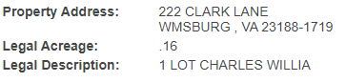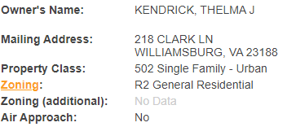

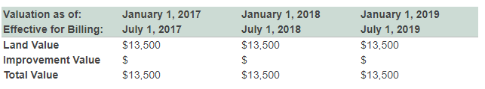

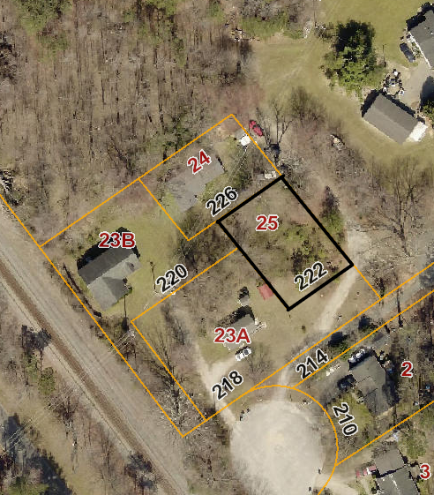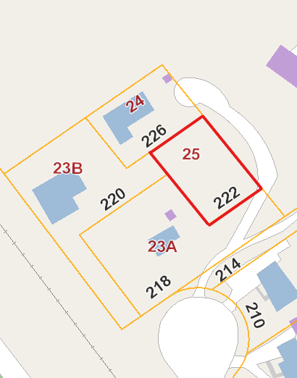

**Parcel 6: James A. Moir, et al.**

**Parcel No. 3240500009**

**LRSN No. 9088**

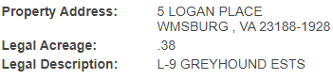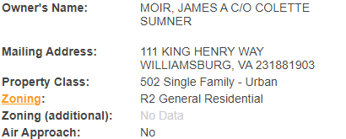

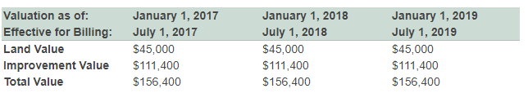

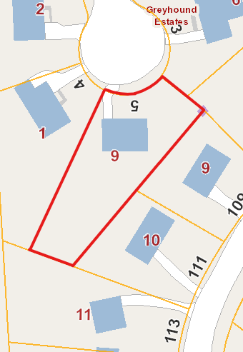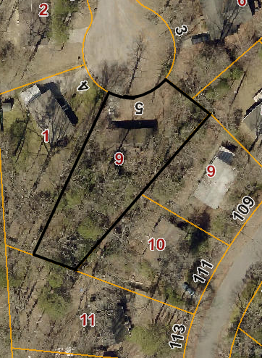

**Parcel 7: Colette Matilda Sumner**

**Parcel No. 3240300010**

**LRSN No. 17238**

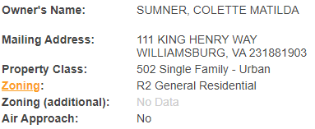

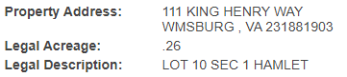

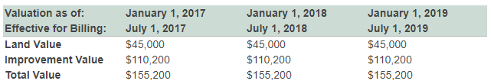

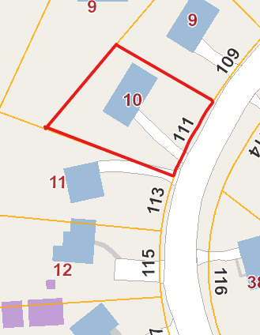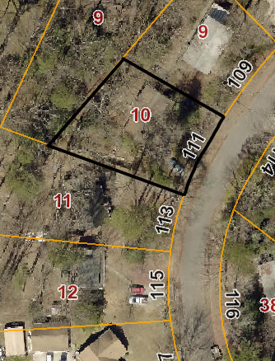

**Parcel 8: Inez Walker, et al.**

**Parcel No. 3110500129**

**LRSN No. 4761**

