Real Estate for Sale by the Auction Method
Thursday – June 30, 2016 – 2:00pm

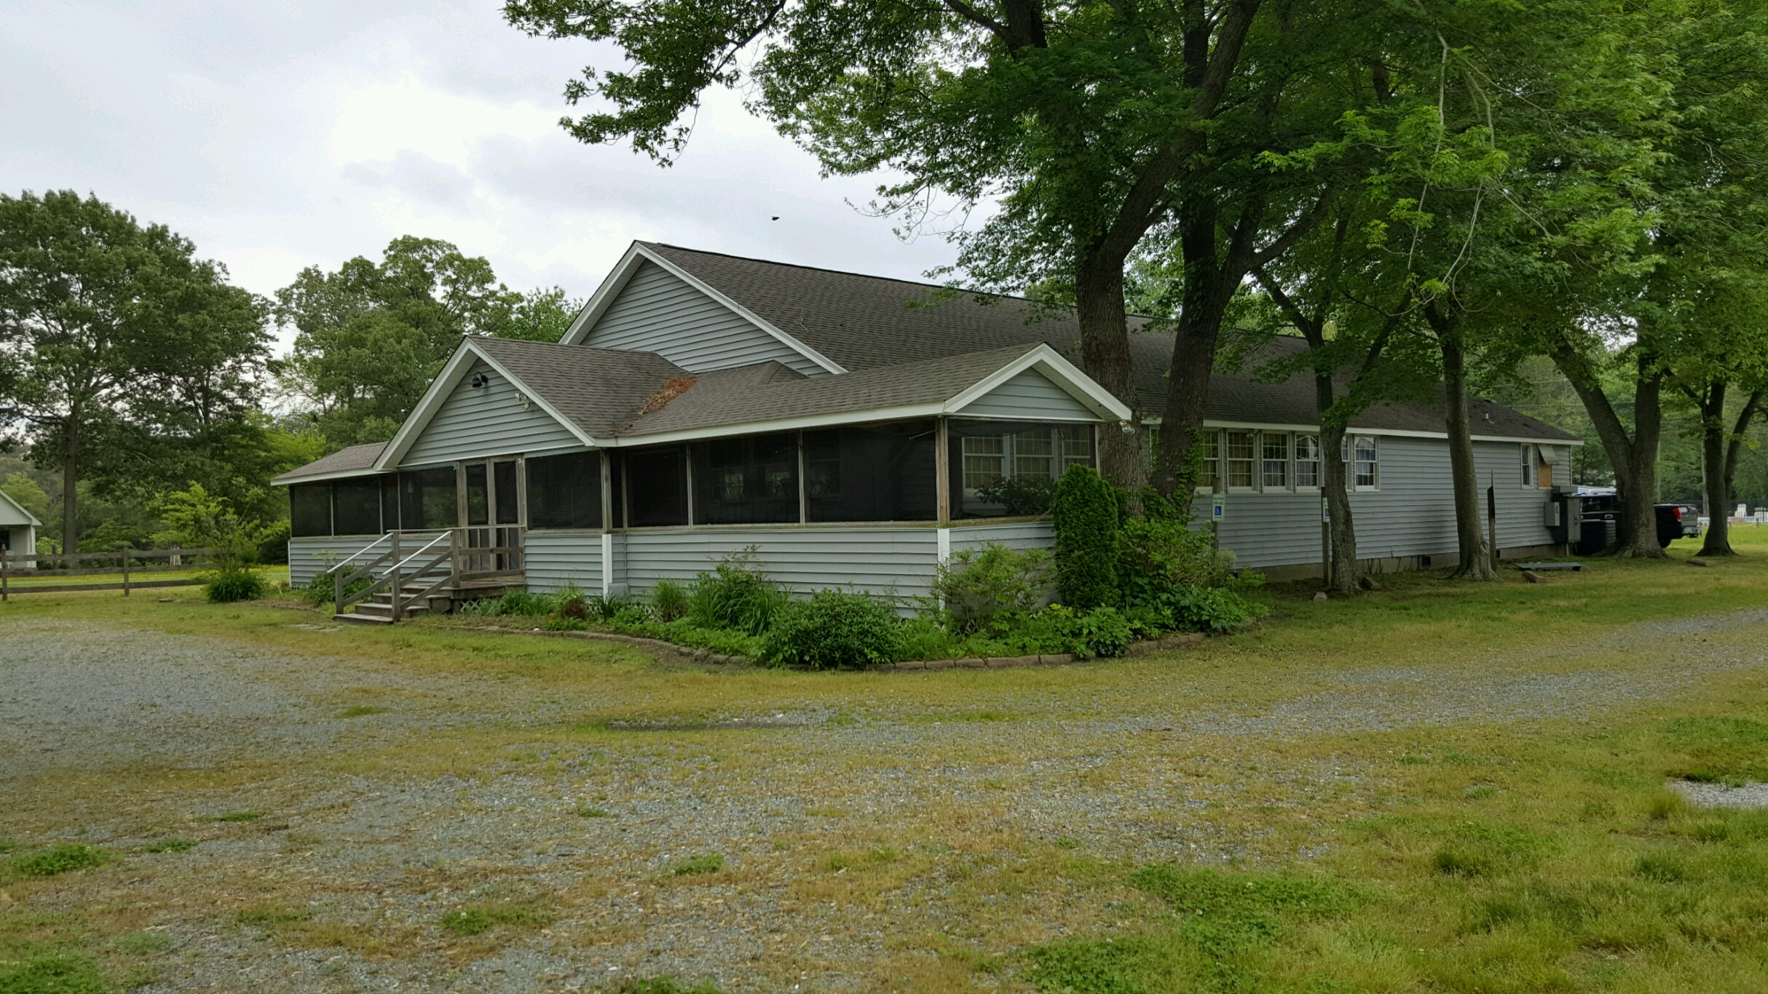

342 Misty Cove Rd
Hallieford, Virginia 23068

Open House on Sunday, June 26th From 1PM – 4PM

Features and Facts
Over 3900 Sq ft w/ an additional 935 Sq ft of Screened Porch
Is in a Community HOA with In-Ground Swimming Pool, Tennis Courts & Access to the River
Could be Re-Opened as a Restaurant
1.0011 Acres

Check our website for more info: www.dixonsauction.com

POWHATAN AUCTIONS, INC.

Inventory & Appraisals – Liquidation/Auction Services

PROPERTY INFORMATION

ADDRESS | 342 Misty Cove Rd  Hallieford, VA 23068
LEGAL DESCRIPTION | Parcel # 5 19 X
LAND VALUE | $50,000
BUILDING VALUE | $121,000
TOTAL ASSESSMENT | $171,000
LOCATION DIRECTIONS | From Richmond Take I-64 E, Take Exit 220 for VA-33 E toward W Point, Continue onto VA-198 E, Turn Left to stay onto VA-198 E/Buckley Hall Rd, Turn Left onto State Rte 626/Hallieford Rd, Turn Left onto Godfrey Bay Rd, Right onto Misty Cove Rd
UTILITIES | Power, Phone
SEWER
WATER
METHOD OF SALE | Public Auction
CLOSING DATE | 45 days – 8/15/16
AUCTION DAY & TIME | June 30, 2016 at 2:00pm
AUCTION LOCATION | 342 Misty Cove Rd  Hallieford, VA 23068
2426 New Dorset Circle
Powhatan, Virginia 23139
(804) 598-5099 / Fax: (804) 598-5591
visit us online at www.dixonsauction.com

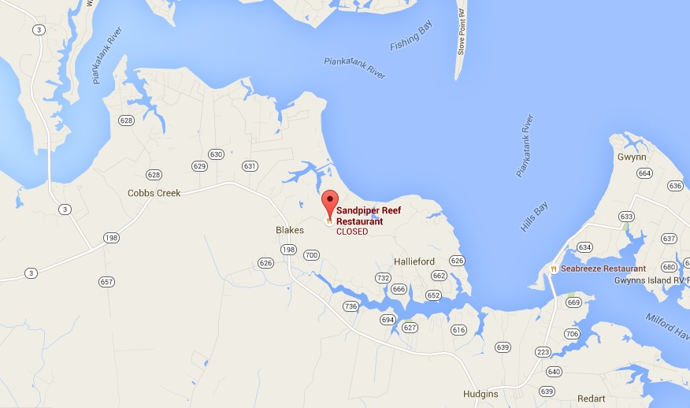



BIDDER TERMS & CONDITIONS

FOR BIDDING ON REAL ESTATE

Registration
No Bidding will be allowed until you are properly registered as a Bidder with Powhatan Auctions, Inc. This will include completing the registration forms. Any individual bidding on behalf of a corporate or limited liability company entity must have the legal capacity to bind a contract; they must also present to Dixon's evidence stating that the bidder has the right and ability to sign and bind the corporation or limited liability company in contractual obligations involving real estate. Any individual bidding on behalf of a Limited Partnership must have the legal capacity to bind a contract and be a general partner of the partnership.
Method of Offering
The property will be offered at a public auction if not sold prior to the scheduled auction date.

Purchase Price; Buyer’s Premium

The final purchase price will be the TOTAL OF (i) the amount of the highest bid (“Bid Price”) PLUS a Buyers Premium of 10% of the Bid price. The Buyer’s Premium shall be deposited with Powhatan Auctions, Inc. in the form stated below.
Property Inspections
All potential bidders are advised to inspect the property. Each bidder assumes all risk associated with any such inspection. All grounds, mechanical or operating systems, structures, timber and any other physical aspects should be considered, as well as any and all documents made available. There will be no contingencies for any type of report or research unless noted. Property is made available for inspection on the noted day for the Open House and the day of auction, unless otherwise noted
Property Condition
The property is being offered on an "AS IS WHERE IS" basis and "WITH ALL FAULTS". Seller and Auctioneer/Broker will not make and hereby expressly disclaim making any warranties or representations whatsoever, expressed or implied, written or oral, with respect to the property without limiting its disclaimers; Seller, Agents and Auctioneer/Broker hereby advise all prospective bidders that no warranties or representations will be made regarding: The Area, Size, Shape, Allowable Uses, Zoning, Soil Type or Quality, Flood Planes and Zones or Topological Characteristics of the Land, The property meeting State Standards, Environmental Hazards or Lack Thereof affecting the use of the Property, including but not limited to Asbestos, Underground Tanks, Above Ground Tanks, Dumping Grounds, or any other environmental concerns. Neither the Seller nor the Auctioneer/Broker make any representation as to the accuracy or completeness of any information contained within the Brochure, Due Diligence Package or any other material. By participation in the auction, all Bidders shall be deemed to represent that they have conducted their own thorough investigation of all documents, information and all other factors concerning the property offered. It will also be deemed that the bidder has not relied on any statements, information or representations made by any individual associated with the property, Seller or Auctioneer.
Contingencies
All bids shall be made on an "AS IS WHERE IS" basis with no warranty or guarantee on any nature. Absolutely no contingencies will be allowed including to but not limited to: financing, environmental, zoning, property or system inspection or any other issue unless otherwise specifically agreed to in writing by Seller, which Seller shall be under no obligation to do.
Confirmation of Sale
The property will be offered with reserve unless expressly noted. Seller will have one hour from the completion of the auction to confirm or refuse all bids on the property should the bidding not reach the reserve amount on the property.

Settlement
The successful high bidder will be required to sign the approved Real Estate Purchase Agreement immediately after the conclusion of the bidding. At this time, the applicable funds will be collected. The down payment of 10% of the final successful bid price shall be presented in the form of cash, cashiers check, or a personal bank letter of guarantee. Title will be transferred by Special Warranty Deed at closing, which shall be within 45 days of the auction. Buyer agrees and acknowledges and agrees that time is of the essence with regard to the closing date in the contract; this means that Buyer must close on or before the date stated in the contract unless (i) Seller agrees, in writing to an extension of the closing date (which extension Seller shall in no event be obligated to give) or (ii) the failure to close is as a result of Seller needing to take action to correct any title defects or questions, in which event closing will be delayed for a reasonable period of time to allow Seller to correct the defects or questions.. Any requests for extension of the closing date must be authorized by Seller. and will result in Buyer paying an additional amount of $240.00 per day for each day Buyer fails to close after the closing date of ___August 15, 2016_____. Possession of the real estate shall be delivered upon settlement and recordation of the deed.
2426 New Dorset Circle
Powhatan, Virginia 23139
(804) 598-5099 / Fax: (804) 598-5591
visit us online at www.dixonsauction.com


COOPERATING BROKER TERMS & CONDITIONS
FOR OFFERING BIDS AND RECEIVING A COMMISSION
ON REAL ESTATE AUCTIONED BY DIXON’S

Requirements for You to Receive a Commission
1. You must show the real property prior to the auction to the prospective bidder located by you
2. The registration and bidding forms must indicate that you are the broker representing the bidder
3. Your bidder must make a written opening bid in advance of the auction; the opening bid must be on the registration and bidding forms supplied by Dixon’s
4. The bidder represented by you must be the winning bidder
5. Your bidder must execute a purchase contract provided by Dixon’s
5. You must sign the purchase contract to indicate that you are the broker representing the purchaser
6. Your bidder must close on the purchase pursuant to the contract terms.

GENERAL INFORMATION

Property Inspections: All potential bidders are advised to inspect the property. Each bidder assumes all risk associated with any such inspection. All grounds, mechanical or operating systems, structures, timber and any other physical aspects should be considered, as well as any and all documents made available. There will be no contingencies for any type of report or research unless noted. Property is made available for inspection on the noted day for the Open House and the day of auction, unless otherwise noted.

Property Condition: The property is being offered on an "AS IS WHERE IS" basis and "WITH ALL FAULTS". Seller and Dixon’s will not make and hereby expressly disclaim making any warranties or representations whatsoever, expressed or implied, written or oral, with respect to the property. Without limiting their disclaimers, Seller and Dixon’s hereby advise all prospective bidders that no warranties or representations will be made regarding: The Area, Size, Shape, Allowable Uses, Zoning, Soil Type or Quality, Flood Planes and Zones or Topological Characteristics of the Land, the property meeting State Standards, Environmental Hazards or Lack Thereof affecting the use of the Property, including but not limited to Asbestos, Underground Tanks, Above Ground Tanks, Dumping Grounds, or any other environmental concerns. Neither the Seller nor the Dixon’s make any representation as to the accuracy or completeness of any information contained within the Brochure, Due Diligence Package or any other material. By participation in the auction, all Bidders shall be deemed to represent that they have conducted their own thorough investigation of all documents, information and all other factors concerning the property offered. It will also be deemed that the bidder has not relied on any statements, information or representations made by any individual associated with the property, Seller or Dixon’s.

Contingencies: All bids shall be made on an "AS IS WHERE IS" basis with no warranty or guarantee on any nature. Absolutely no contingencies will be allowed including but not limited to: financing, environmental, zoning, property or system inspection or any other issue unless otherwise specifically agreed to in writing by Seller in the purchase contract, which Seller shall be under no obligation to do.

Confirmation of Sale: The property will be offered with reserve unless expressly noted. Seller will have one hour from the completion of the auction to confirm or refuse all bids on the property should the bidding not reach the reserve amount on the property.

Settlement: The successful high bidder will be required to sign the approved Real Estate Purchase Contract immediately after the conclusion of the bidding. At this time, the applicable funds will be collected. The deposit of 10% of the final successful bid price shall be presented in the form of cash, cashiers check, or a personal bank letter of guarantee. Title will be transferred by Special Warranty Deed at closing, which shall be within 45 days of the auction. Buyer agrees and acknowledges and agrees that time is of the essence with regard to the closing date in the contract; this means that Buyer must close on or before the date stated in the contract unless (i) Seller agrees, in writing to an extension of the closing date (which extension Seller shall in no event be obligated to give) or (ii) the failure to close is as a result of Seller needing to take action to correct any title defects or questions, in which event closing will be delayed for a reasonable period of time to allow Seller to correct the defects or questions.. Any requests for extension of the closing date must be authorized by Seller and will result in Buyer paying an additional amount of $240.00 per day for each day Buyer fails to close after the closing date set forth in the contract. Possession of the real estate shall be delivered upon settlement and recordation of the deed.

Commission and Payment: Dixons agrees to pay to selling broker a fee of 3% of the bid price and as a co-op commission, said co-op commission will be paid to the co-op broker by the Closing Attorney at Time of Closing, providing brokers bidder is the high bidder and closes on the purchase pursuant to contract terms.

POWHATAN AUCTIONS, INC.

Inventory & Appraisals – Liquidation/Auction Services

CLIENT REGISTRATION AND OPENING BID AGREEMENT

FOR REAL ESTATE SOLD AT AUCTION
FULL NAME
IF PURCHASING FOR COMPANY, GIVE COMPANY NAME
STREET ADDRESS
CITY & STATE | ZIP
TELEPHONE (AREA CODE) | DAYTIME HOME
EMAIL ADDRESS
FORM OF PAYMENT

Property Location___342 Misty Cove Rd_________________
Or Legal ___Parcel # 5 19 X_____________
City/County___County of Mathews_______

By submission of the following opening bid on the above described property I am signifying my intention to purchase said property and am submitting said bid via the below identified Broker/Agent/Client. I therefore am authorizing the Auctioneer to cause to be entered on my behalf the following opening bid upon the commencement of the actual auction at the prescribed location, day and time. Client understands the submission of an opening bid herein in no way obligates the auction firm or auctioneer to commence a sale per se. The auction firm reserves the right to not cry the opening bid for any sale, the commencement of which may be detrimental to the Sellers best interests and goals. Broker/Agent/Client has read and understands the terms and conditions of “The Broker/Agent/Client Participation Agreement” and by so here submitting a client registration and opening bid further agrees to such.

Broker____________________________________________________ Phone___________________________

Agent_____________________________________________________ Phone___________________________

Client_____________________________________________________ Phone___________________________

Address_______________________________________City_________________St__________Zip___________

Opening Bid Amount:___________________ Plus 10% Buyer’s Premium_______________________
Equals TOTAL PURCHASE PRICE $_________________

I personally guarantee payment and personally agree to and understand all of the terms and conditions of this auction, As set forth in the Bid Package or from the auction stand. I further understand that I am liable for payment of all real Estate purchased on my number and that Powhatan Auctions, Inc. has the right to pursue the legal means necessary to collect any funds due and that I am personally liable for any costs incurred in the collection of said funds (i.e. expenses of re-auctioning the property, any deficit realized on a resale from the original selling price, any commission Powhatan Auctions, Inc., the original sales price, Buyer’s Premium, and deposits paid plus any attorneys fees, court costs, and all incidental damages or charges involved.) Bidders and purchaser acknowledge that disclosure of the brokerage relationship, if any, was made to them by the real estate licensee involved in this transaction when specific assistance
Was first rendered and confirmed in writing by the signing of this form. Powhatan Auctions, Inc are agents for the Seller.

(SIGNED)_________________________________________ (DATE)_______________________

PENALTY CLAUSE: In the event that Buyer does not close on time, “Time being of the essence” stipulated in the Agreement of Sale, a monetary penalty will be charged to the Buyer in the amount of $ 240.00 for each day closing has not occurred since the agreed closing date. The sum of the penalty charge will be deducted from the Buyer’s Deposit and any deficit of deposit will be paid at closing.

