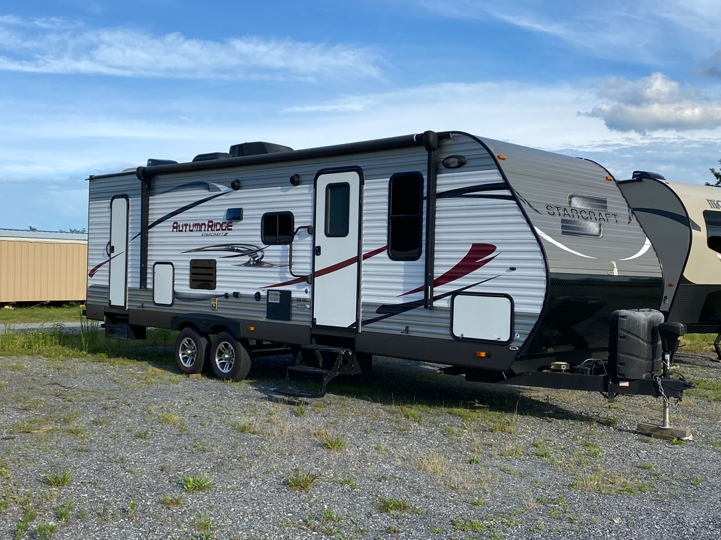 | 2016 STARCRAFT  AUTUMN RIDGE 289BHS  31’ BUNKHOUSE  6254 GROSS WEIGHT  Vin: 1SABS0BP8G2815214
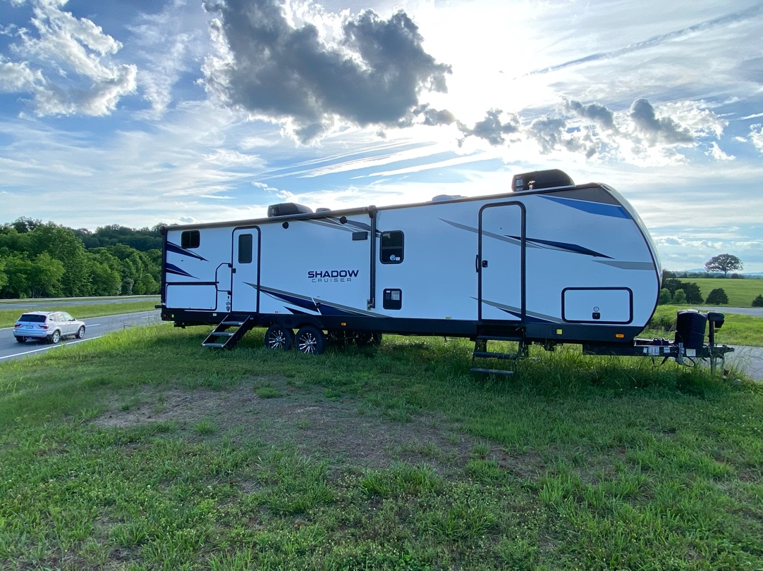 | 2021 SHADOW CRUISER  327BHS  7284 GROSS WEIGHT  31’ Long  Bath and a half  Bunk room w/ 4 bunks  Vin: 5RXDB3724M1475264
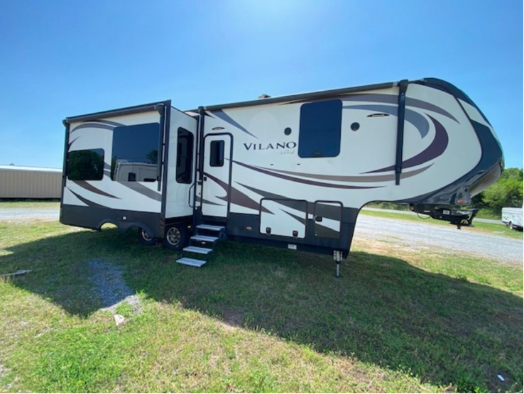 | 2017 VILANO VANLEIGH  326RL  16000 GROSS WEIGHT  34’7” Long  Vin: 1V9FC3426HV206310
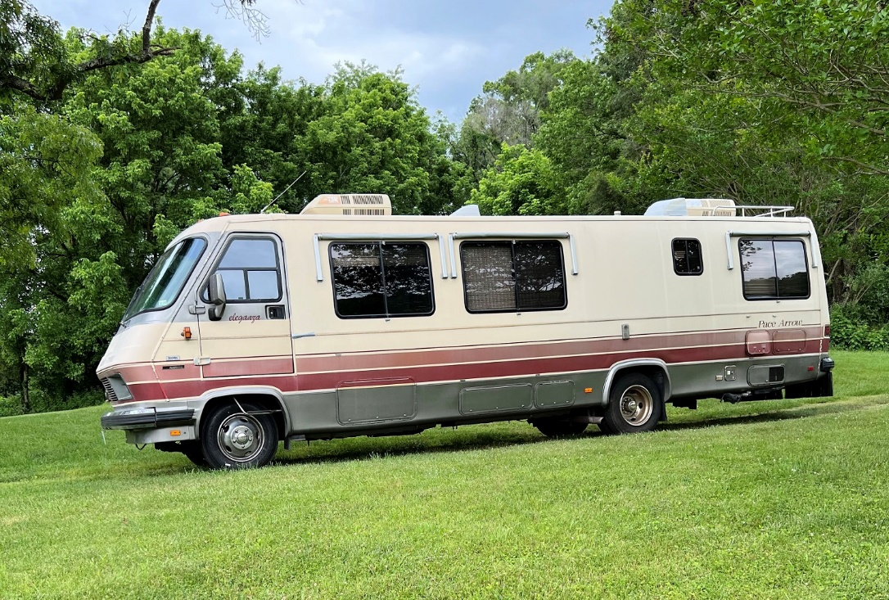 | 1988 Fleetwood Pace Arrow Eleganza  34’ Long  Vin: 1GBKP37W9J3322897
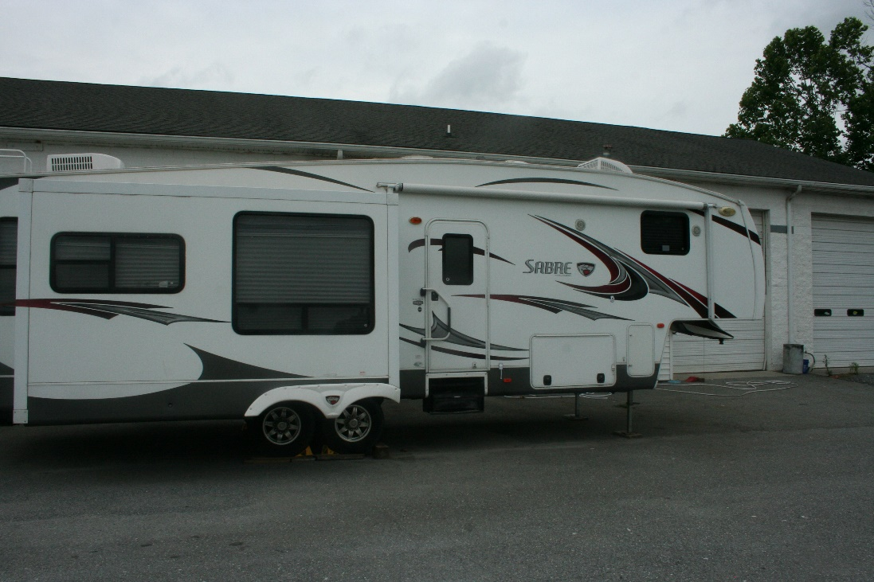 | 2013 Sabre  Vin: 4X4FPAG21D3006522

